# Optimizing User, Group, and Role Management with Access Control and Workflows

**Team ID :** LTVIP2026TMIDS60803

**1. INTRODUCTION**

**1.1 Project Overview**

In modern project management environments, effective control over users, roles, and access permissions is essential to ensure accountability, security, and smooth workflow execution. This project focuses on optimizing user, group, and role management using structured access control mechanisms and automated workflows. The system is designed on the ServiceNow platform to manage project tasks efficiently by clearly defining responsibilities for different users involved in a project.

The project considers a small project team scenario consisting of a Project Manager and Team Members, where tasks need to be assigned, monitored, and completed in a controlled and transparent manner.

**1.2 Purpose**

The main purpose of this project is to design and implement a role-based access control system combined with workflow automation. This ensures that users can only perform actions relevant to their assigned roles, thereby improving task tracking, accountability, and overall project efficiency.

**2. IDEATION PHASE**

**2.1 Problem Statement**

In a small project management team consisting of a Project Manager and a Team Member, the absence of clear role definitions, access controls, and structured workflows leads to confusion in task assignments, lack of accountability, and inefficient progress tracking. There is a need for a centralized system that enforces role-based permissions and automates workflows to streamline project execution.

**2.2 Empathy Map Canvas**

* **Users:** Project Manager, Team Members
* **What they think:**
  + Managers want better visibility and control over tasks
  + Team members want clear instructions and responsibilities
* **What they feel:**
  + Frustration due to unclear task ownership
  + Stress caused by poor tracking mechanisms
* **What they say:**
  + “Who is responsible for this task?”
  + “The task status is not updated properly”
* **What they do:**
  + Manually follow up on tasks
  + Use unstructured communication methods

**2.3 Brainstorming**

Several ideas were explored to address the problem:

* Implementing role-based access control
* Automating task approval workflows
* Assigning users to groups based on responsibilities
* Using ServiceNow for centralized task and workflow management

**3. REQUIREMENT ANALYSIS**

**3.1 Customer Journey Map**

1. User logs into the system
2. Role and permissions are validated
3. Project Manager creates and assigns tasks
4. Team Member receives and updates task status
5. Workflow automatically tracks progress and approvals

**3.2 Solution Requirements**

**Functional Requirements**

* User creation and role assignment
* Group-based access control
* Task creation, assignment, and tracking
* Workflow-based task approval

**Non-Functional Requirements**

* System security and data integrity
* Scalability for additional users
* High availability and reliability

**3.3 Data Flow Diagram (DFD)**

* **User → System:** Login and role verification
* **Project Manager → System:** Task creation and assignment
* **System → Team Member:** Task notification
* **Team Member → System:** Status updates
* **System → Manager:** Progress reports

**3.4 Technology Stack**

* **Platform:** ServiceNow
* **Modules Used:** User Management, Roles, Groups, Workflows
* **Tools:** ServiceNow Studio, Flow Designer

**4. PROJECT DESIGN**

**4.1 Problem–Solution Fit**

The proposed solution directly addresses role confusion and access issues by enforcing strict role-based permissions and automated workflows. This ensures clarity, security, and efficiency throughout the project lifecycle.

**4.2 Proposed Solution**

The system introduces structured user, group, and role management combined with workflow automation. Each user is assigned specific permissions based on their role, ensuring controlled access and clear responsibility.

**4.3 Solution Architecture**

* User Interface (ServiceNow Portal)
* Role-Based Access Control Layer
* Workflow Automation Engine
* Database for user and task records

**5. PROJECT PLANNING & SCHEDULING**

**5.1 Project Planning**

The project was executed in phases:

1. Requirement analysis
2. System design
3. Role and group configuration
4. Workflow implementation
5. Testing and validation

**6. FUNCTIONAL AND PERFORMANCE TESTING**

**6.1 Performance Testing**

* Verified system response during multiple user logins
* Tested task workflow execution time
* Ensured access restrictions work correctly for different roles

**7. RESULTS**

**7.1 Output Screenshots**

* User and role creation screen
* Task assignment dashboard
* Workflow execution and approval screen

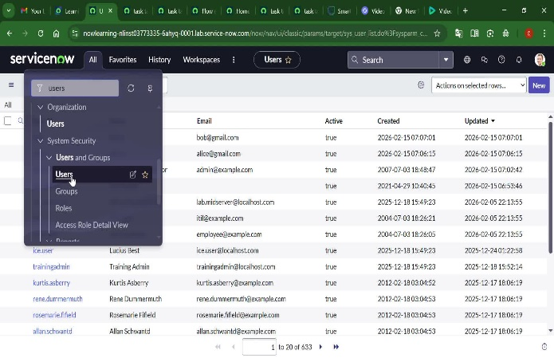 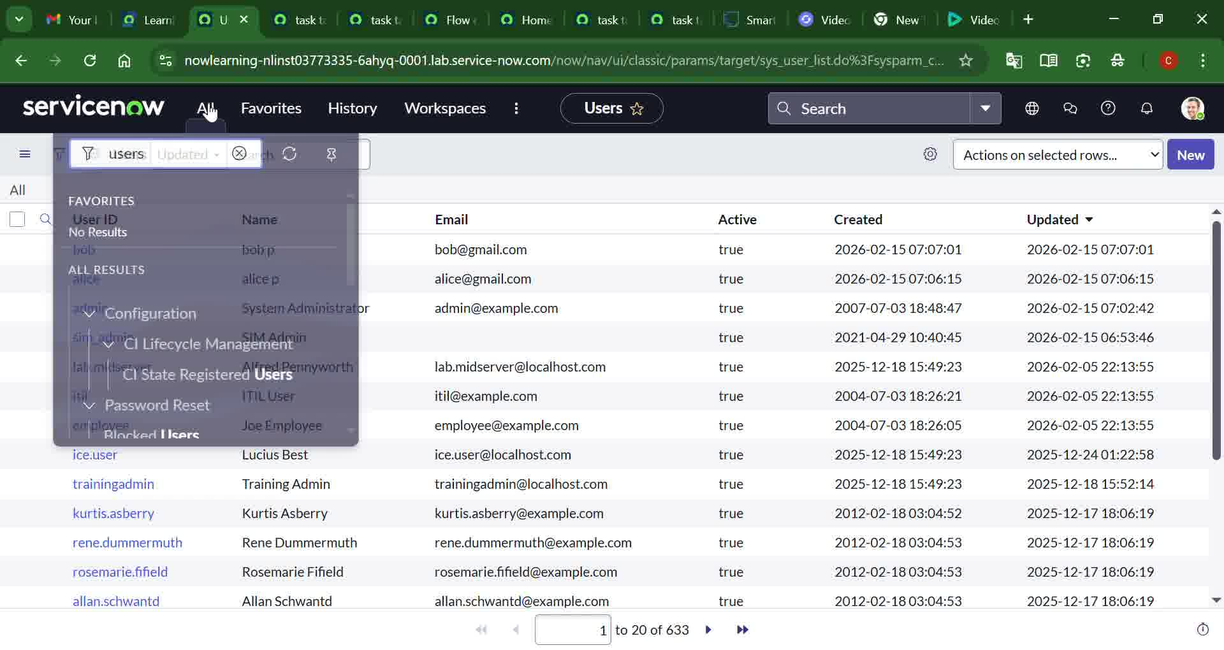

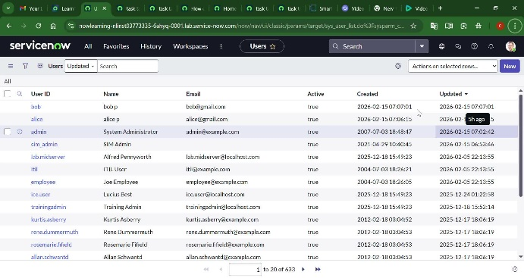 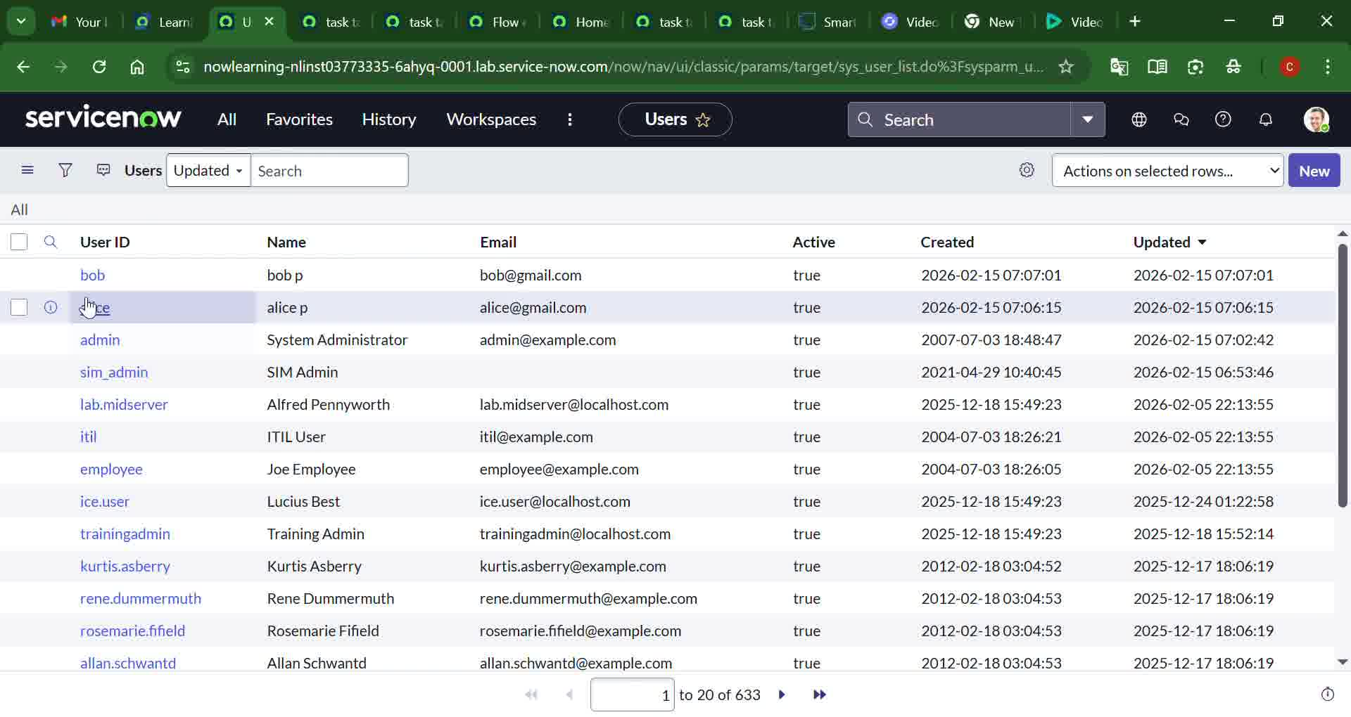

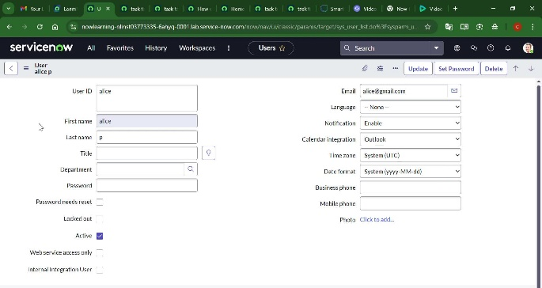 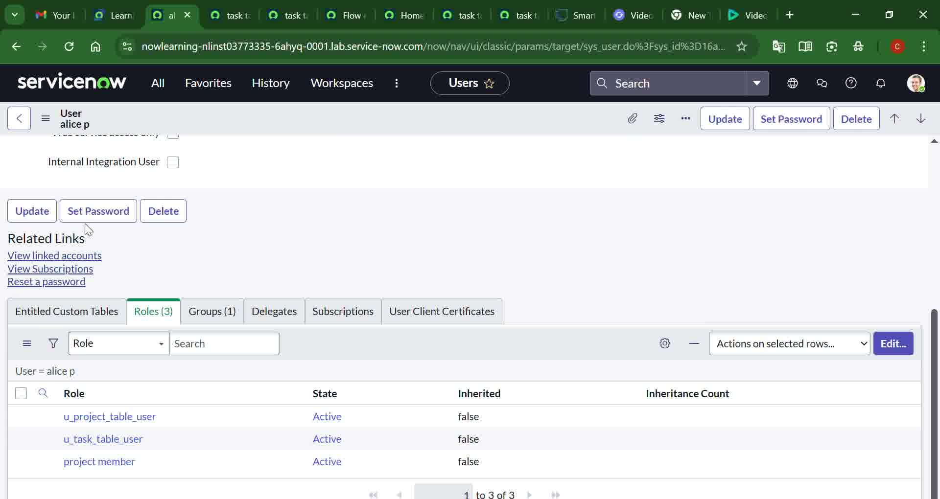

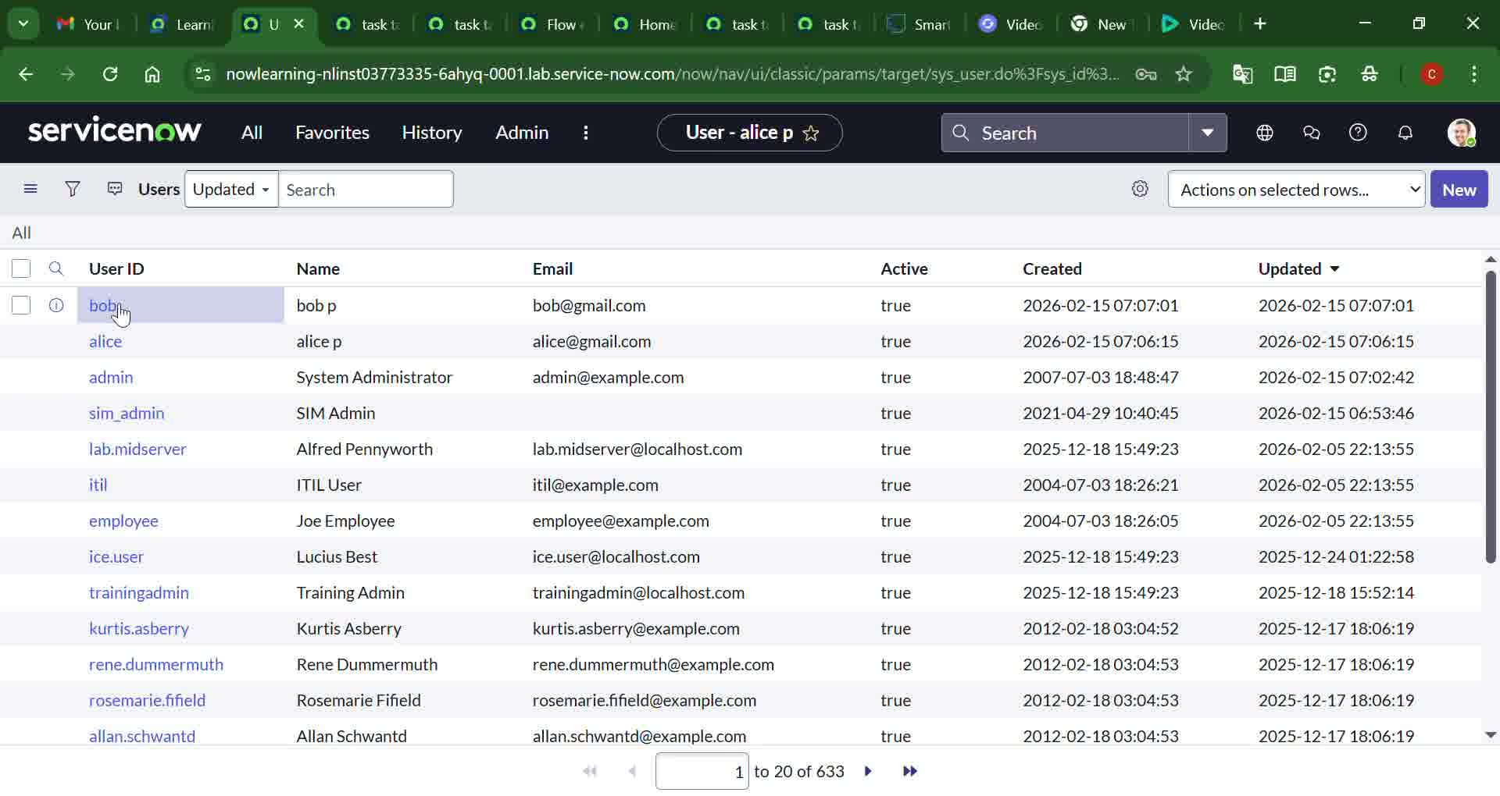 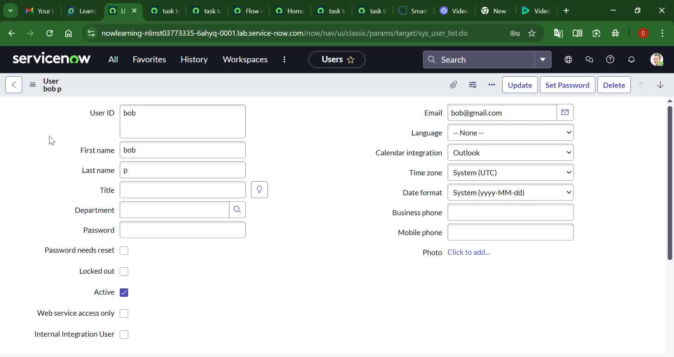

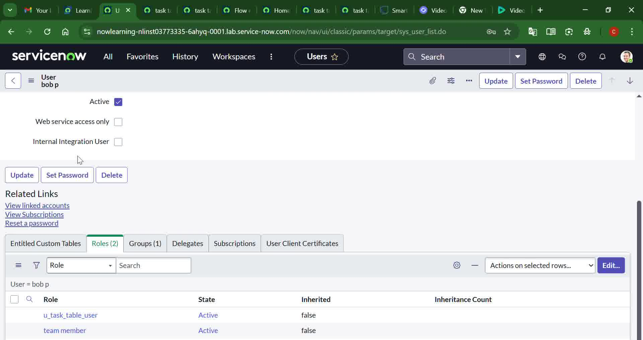 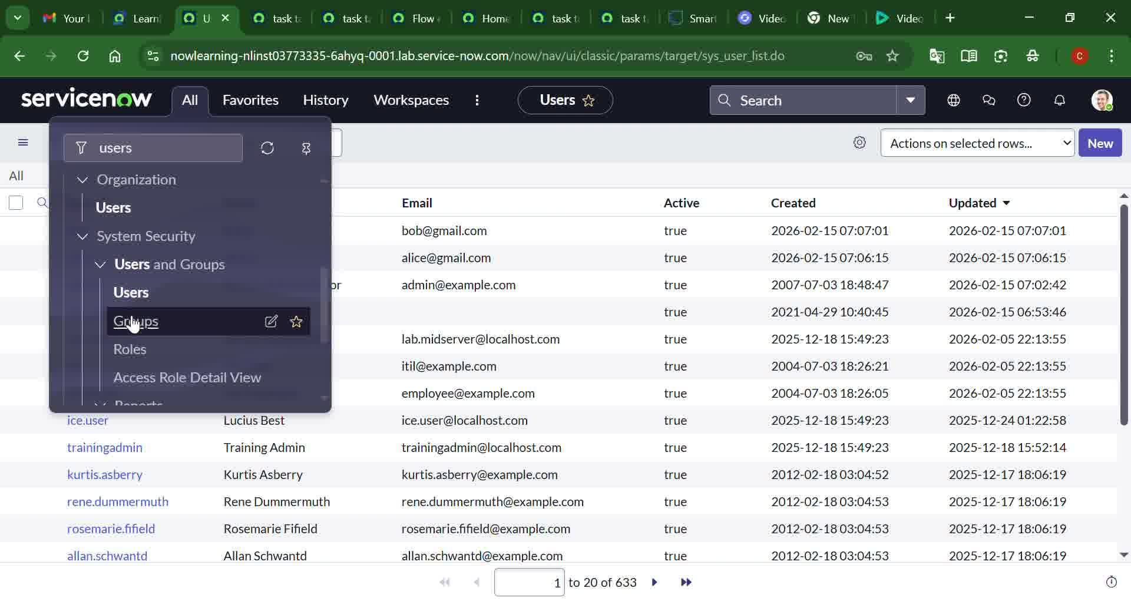

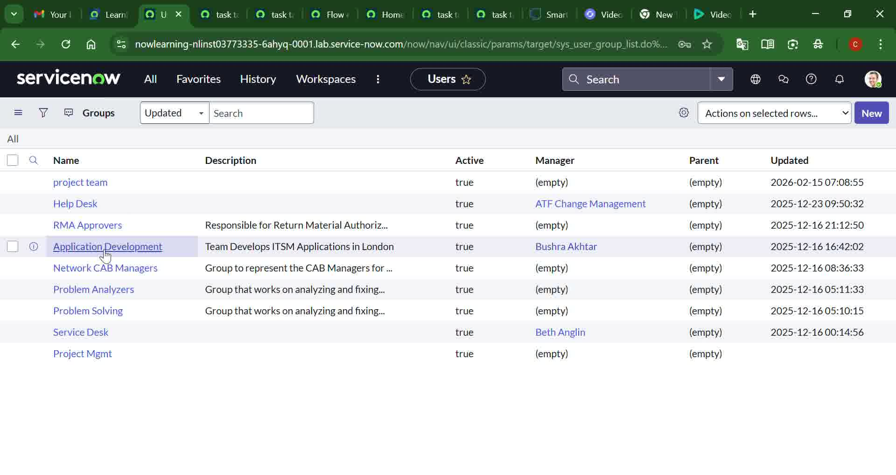 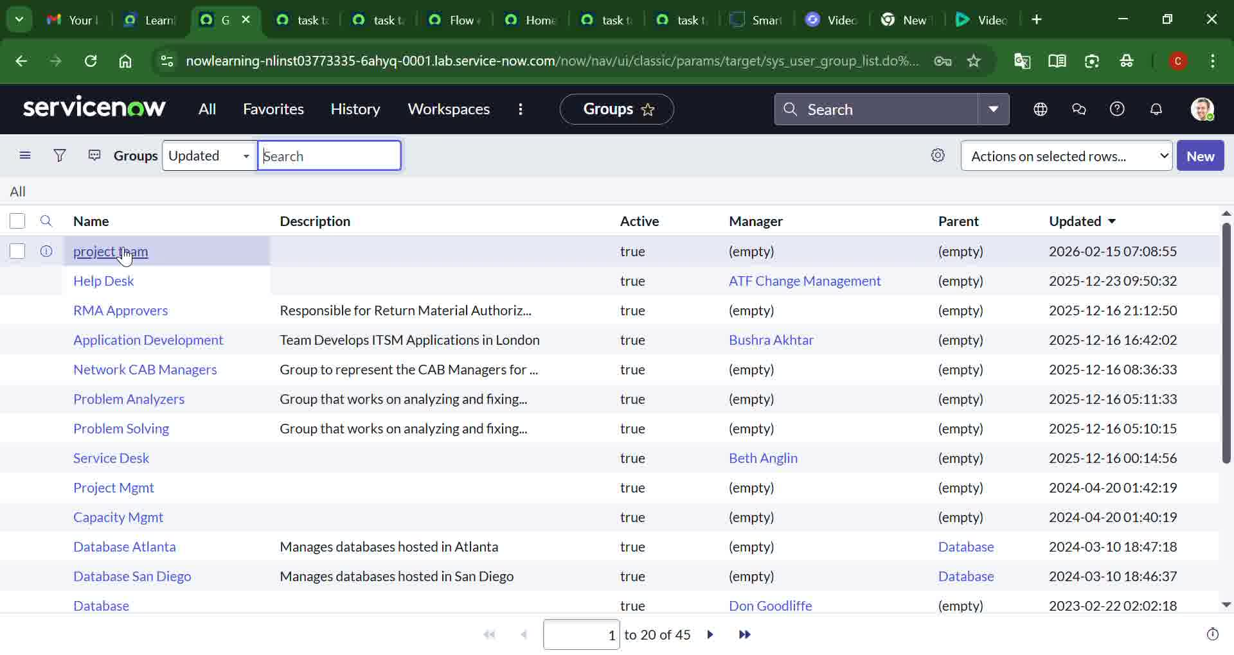

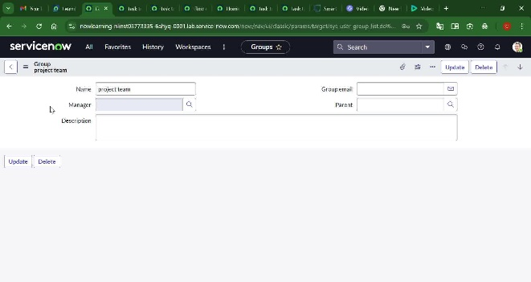 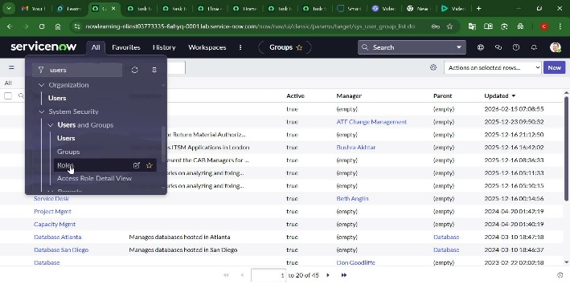

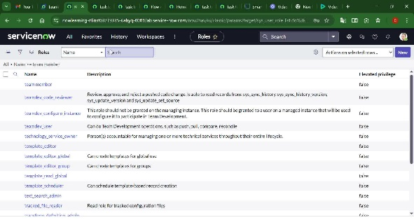 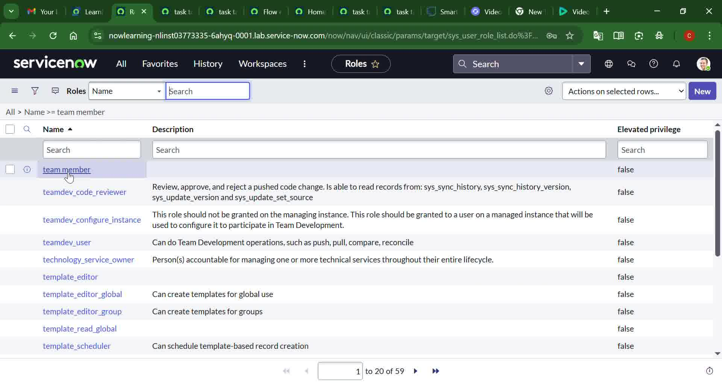

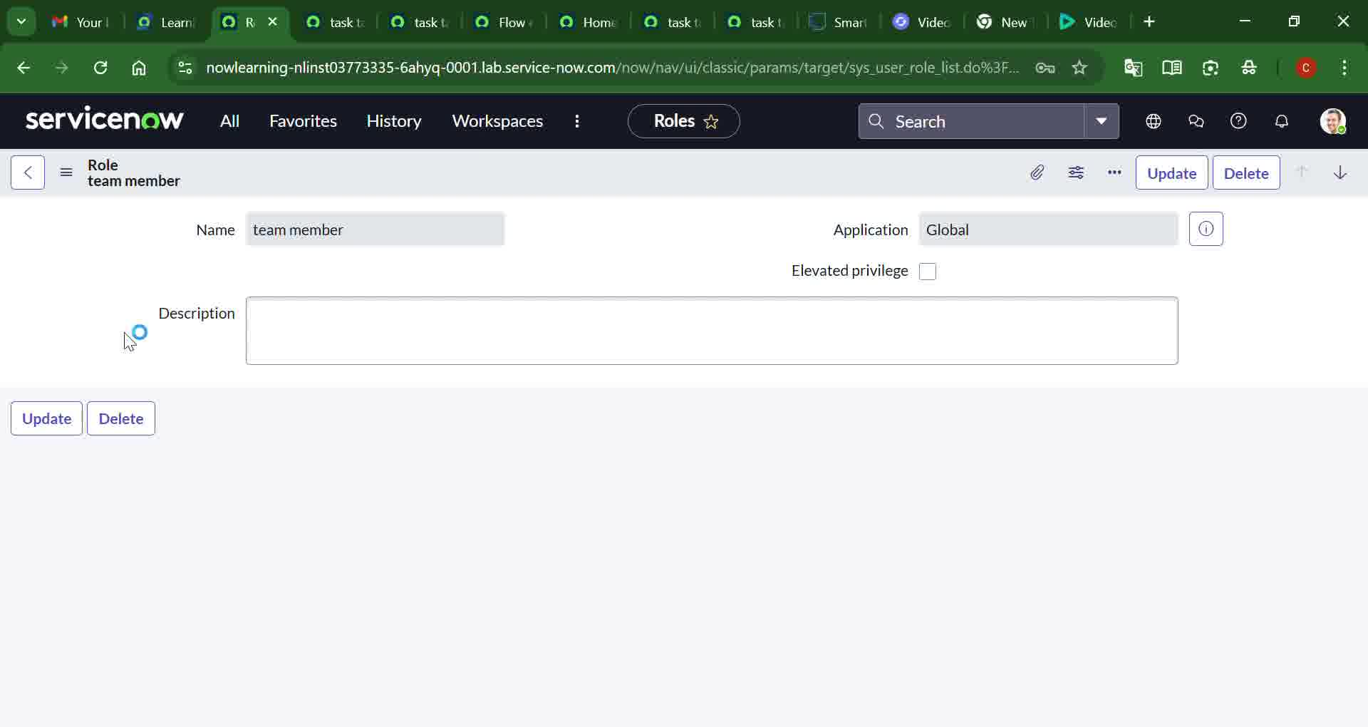 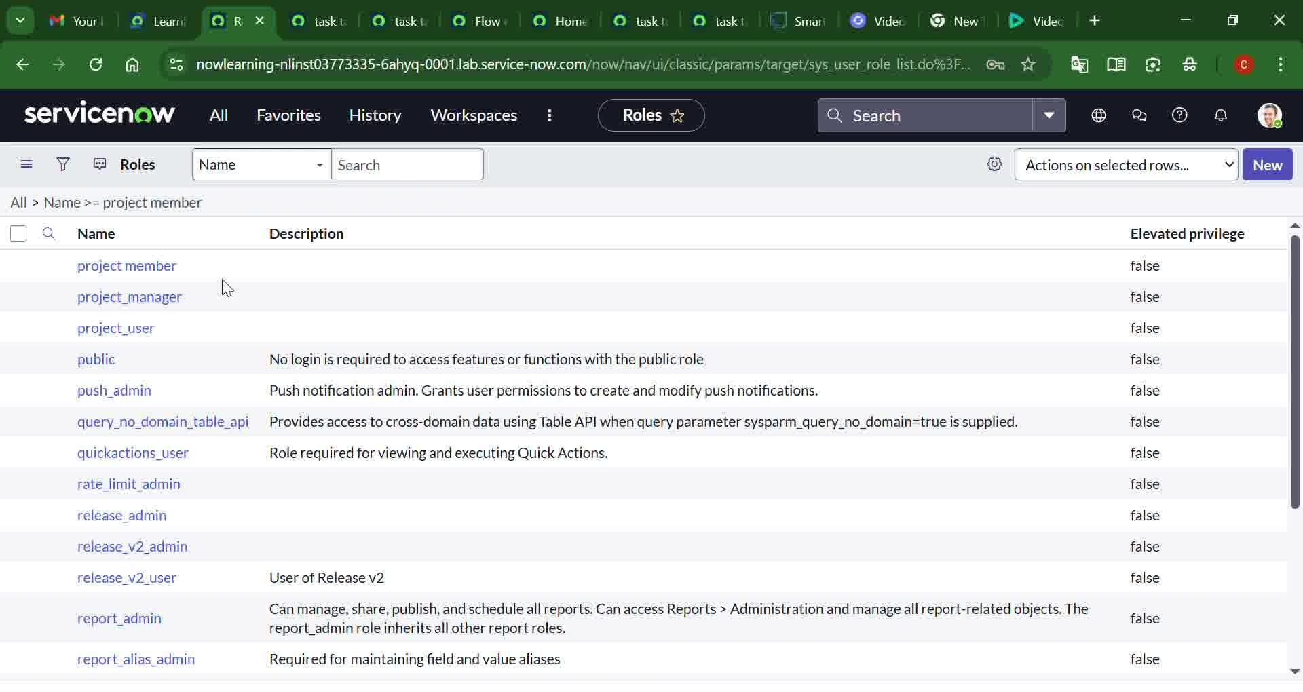

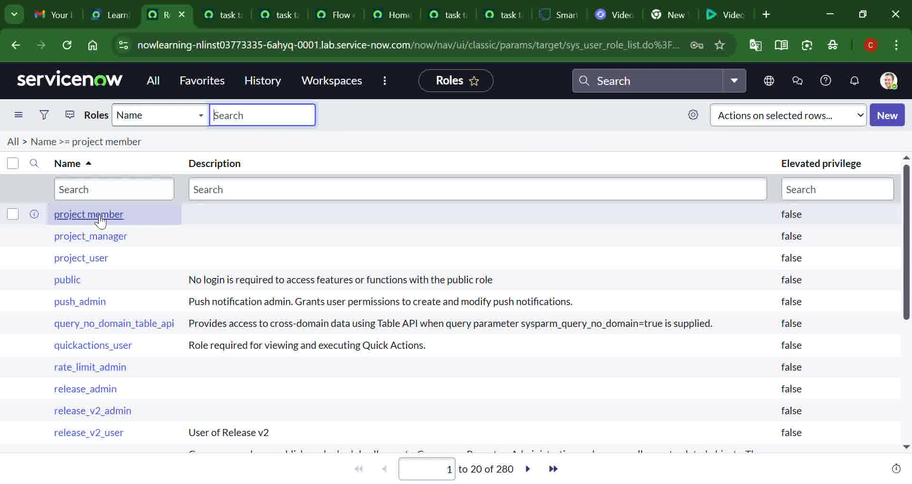 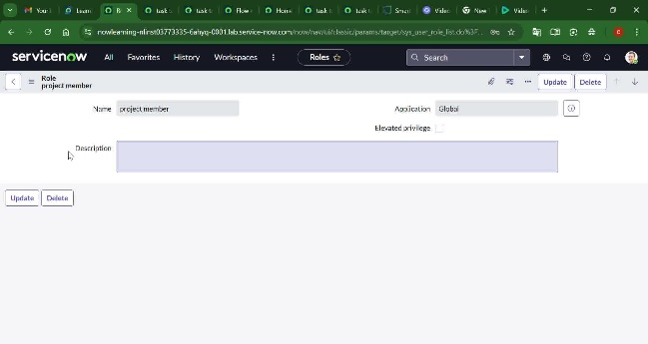

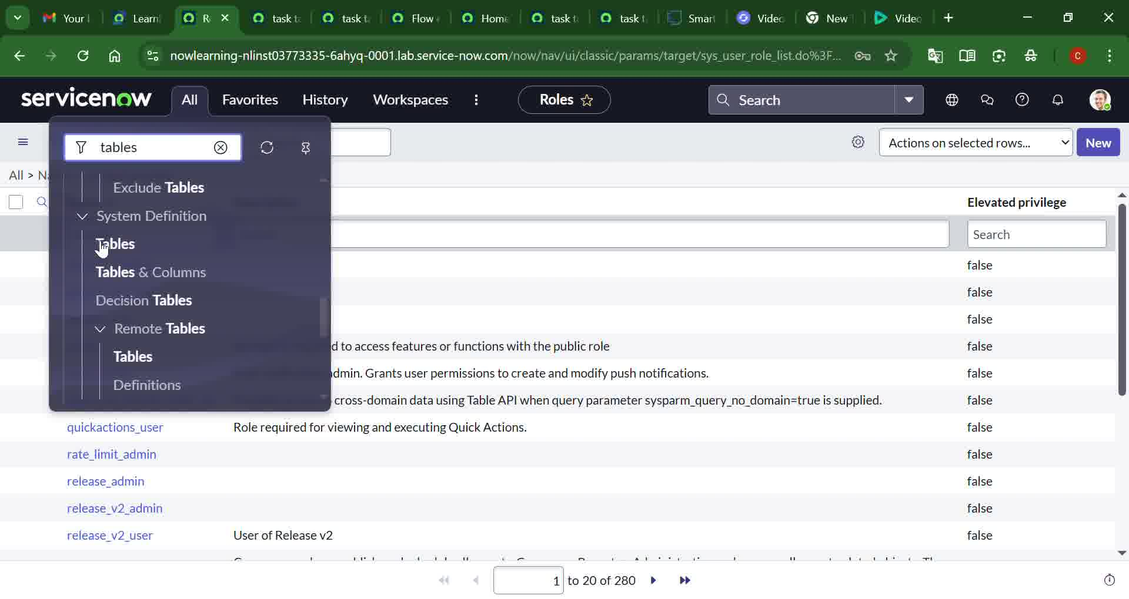 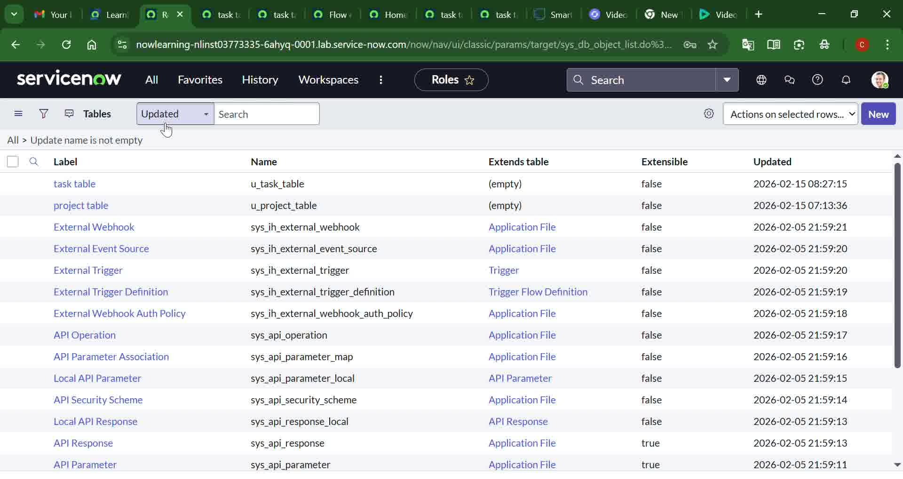

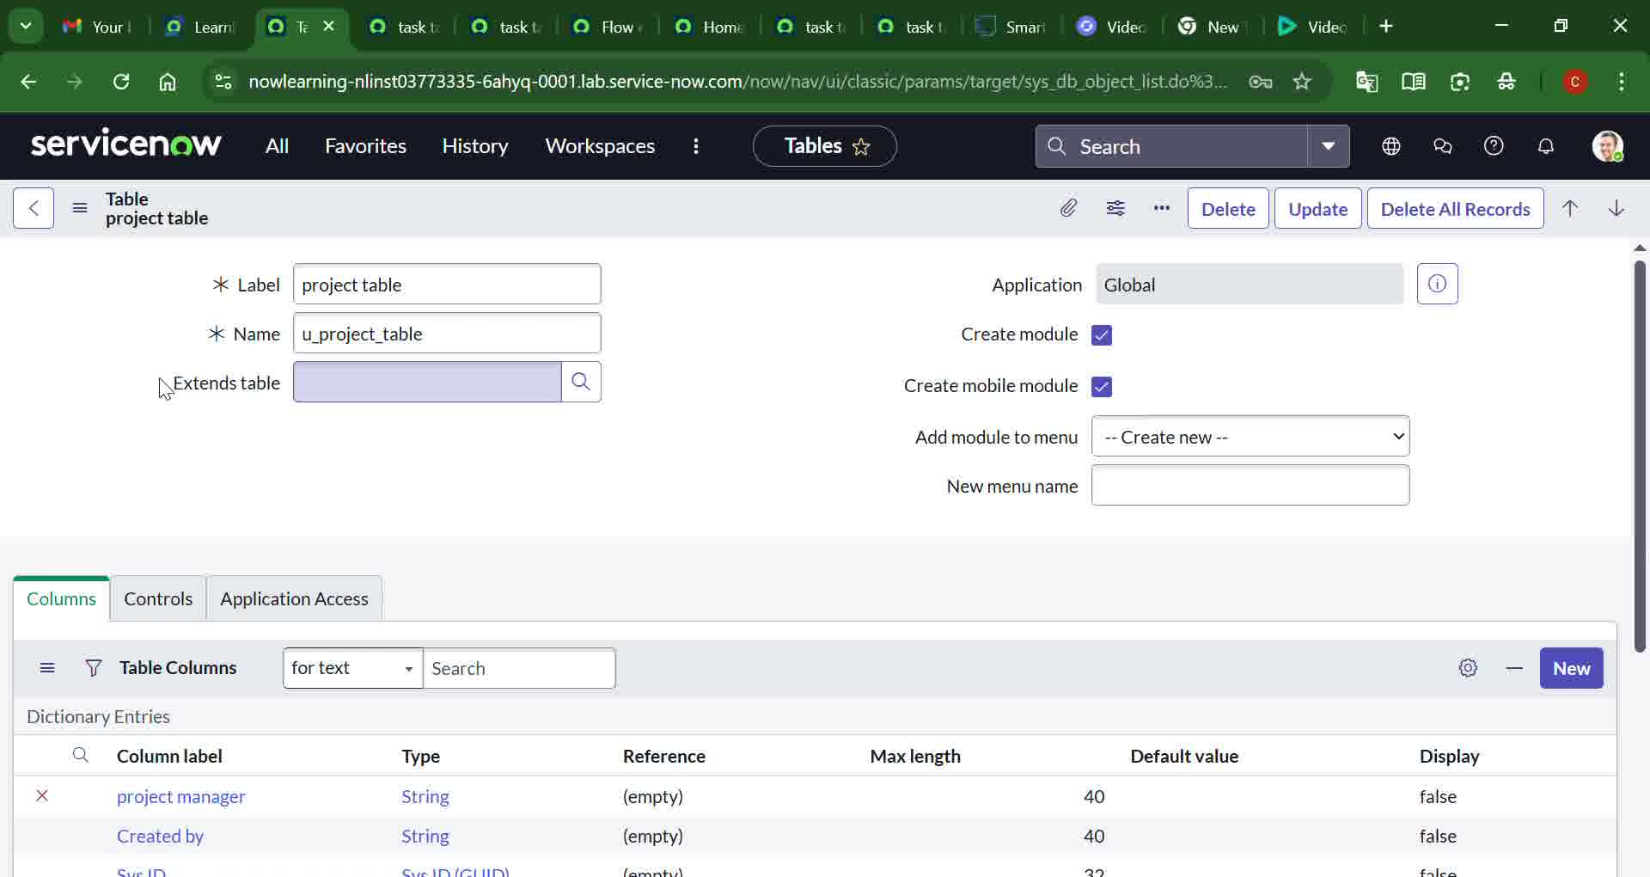 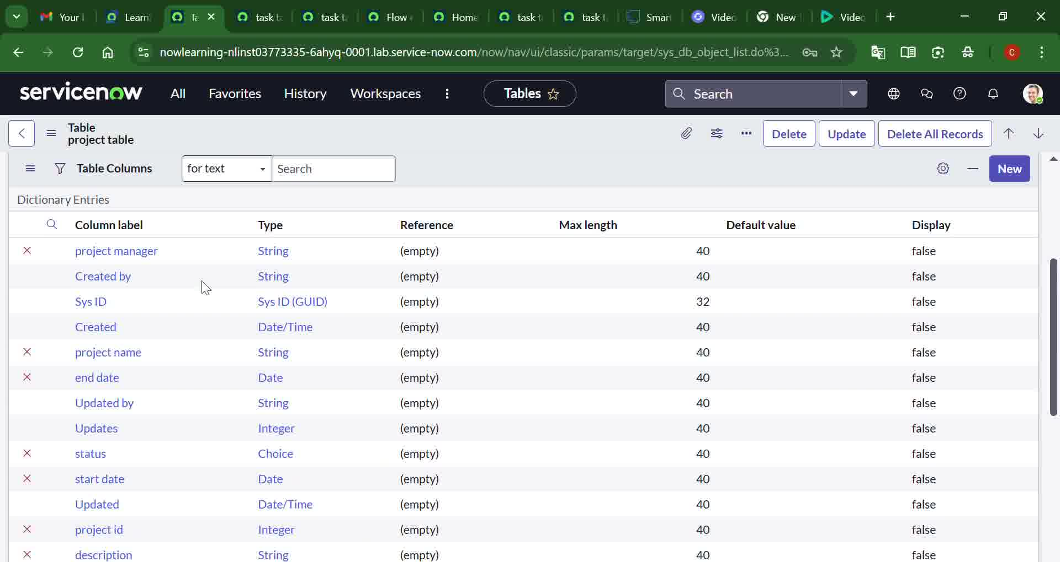

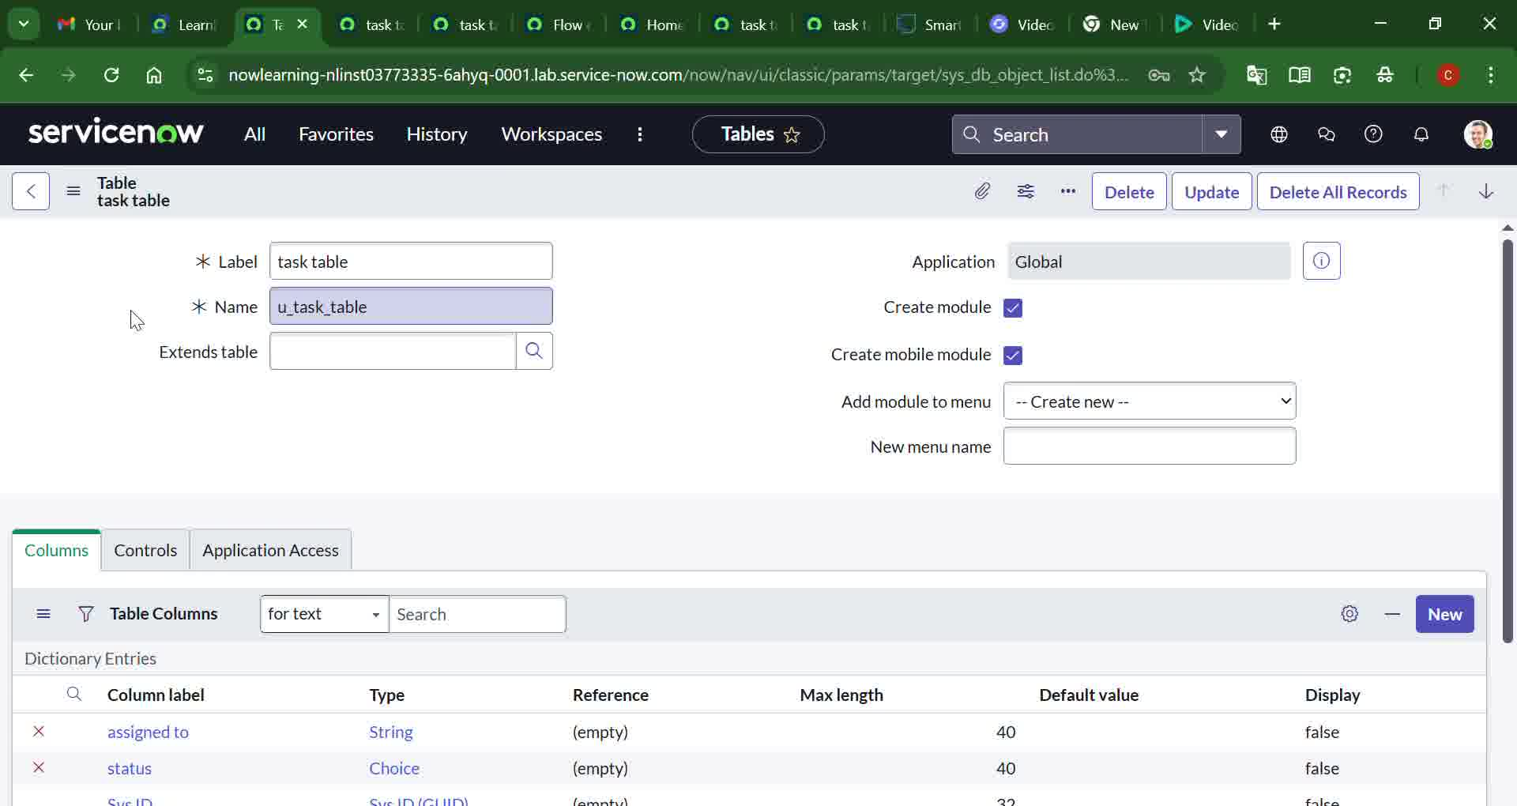 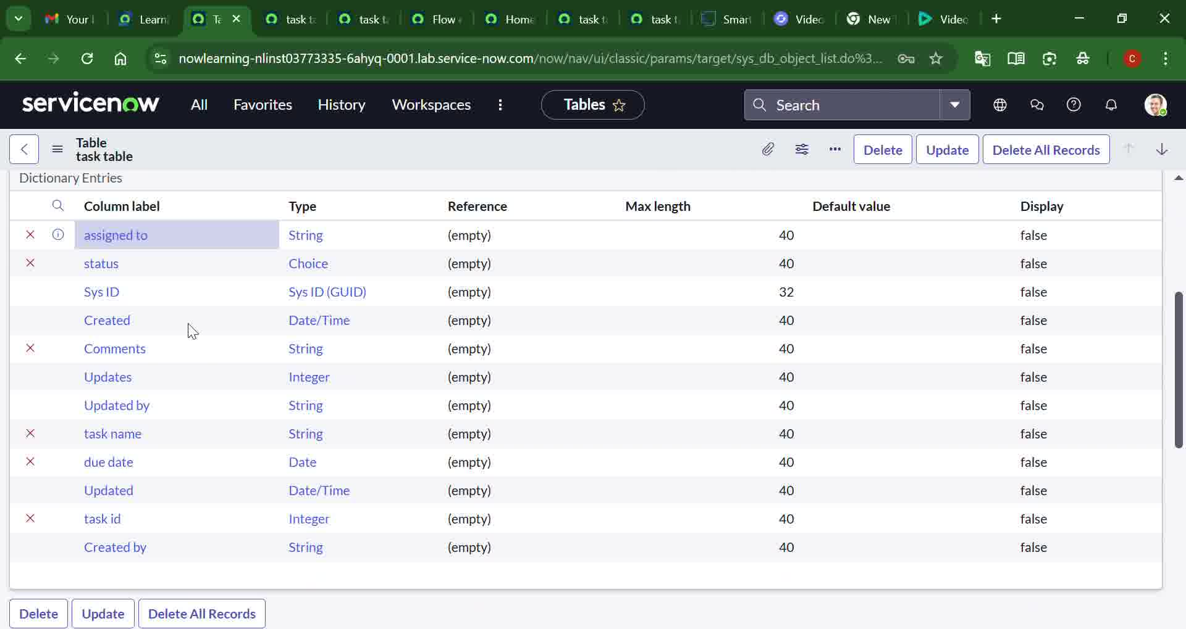

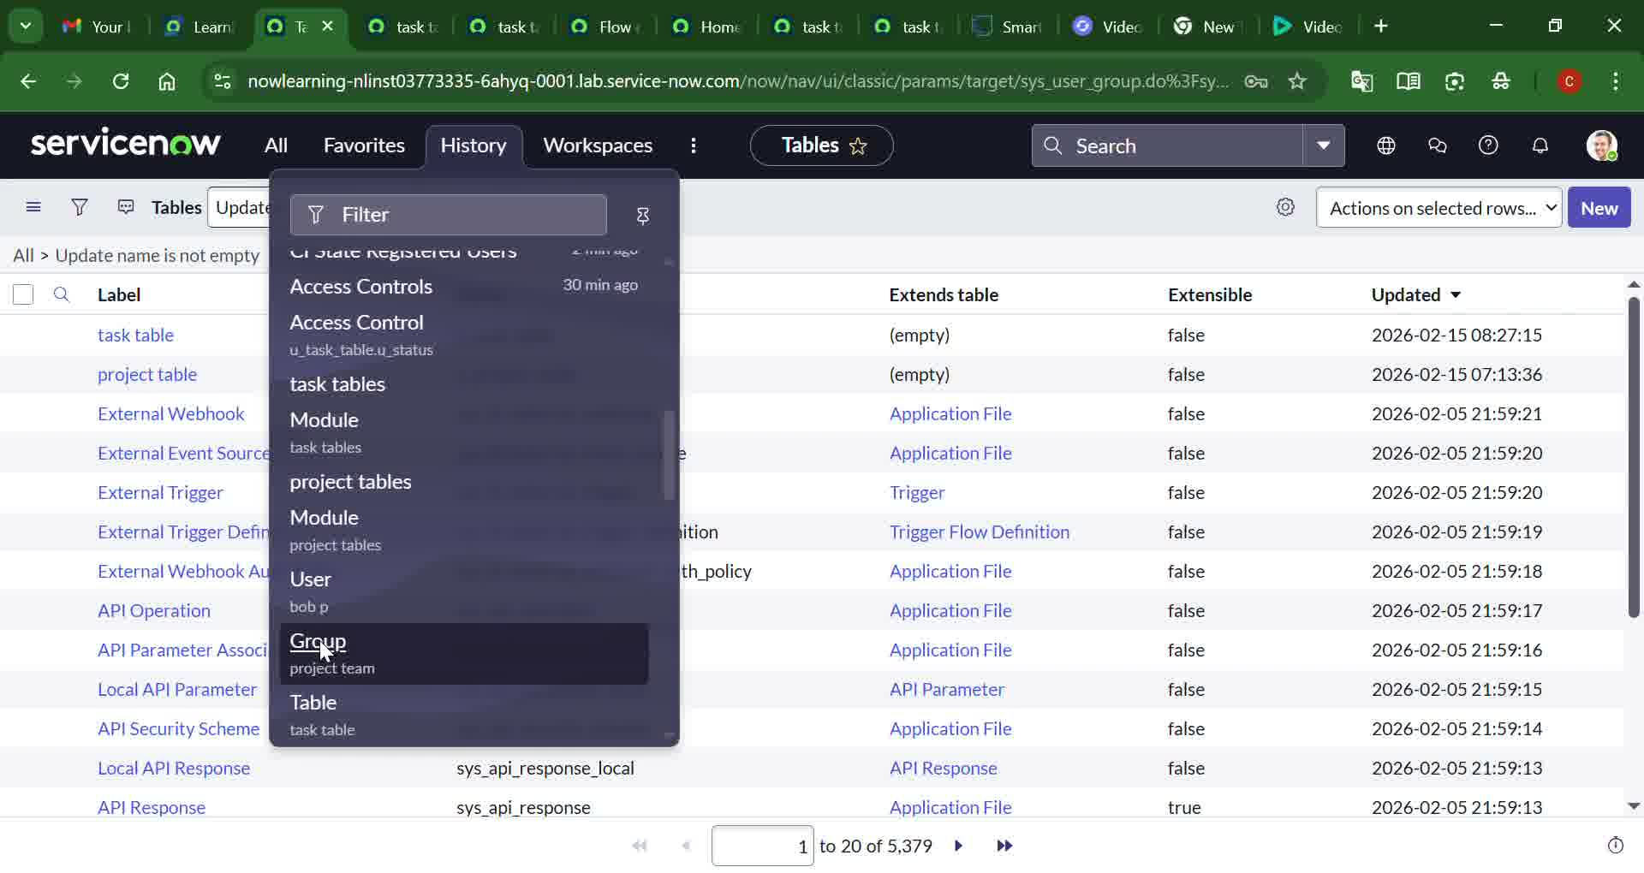 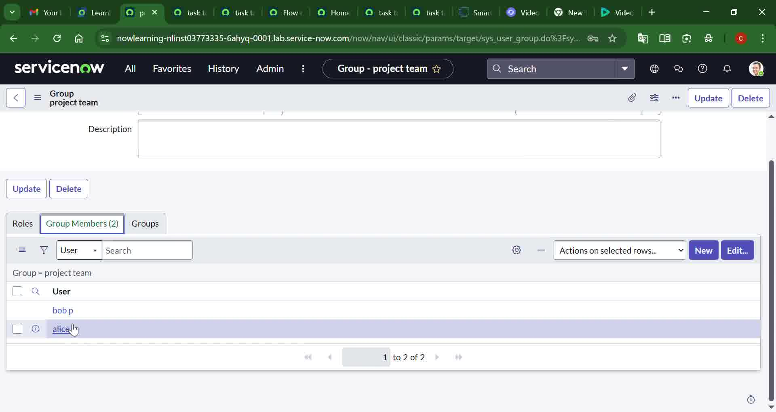

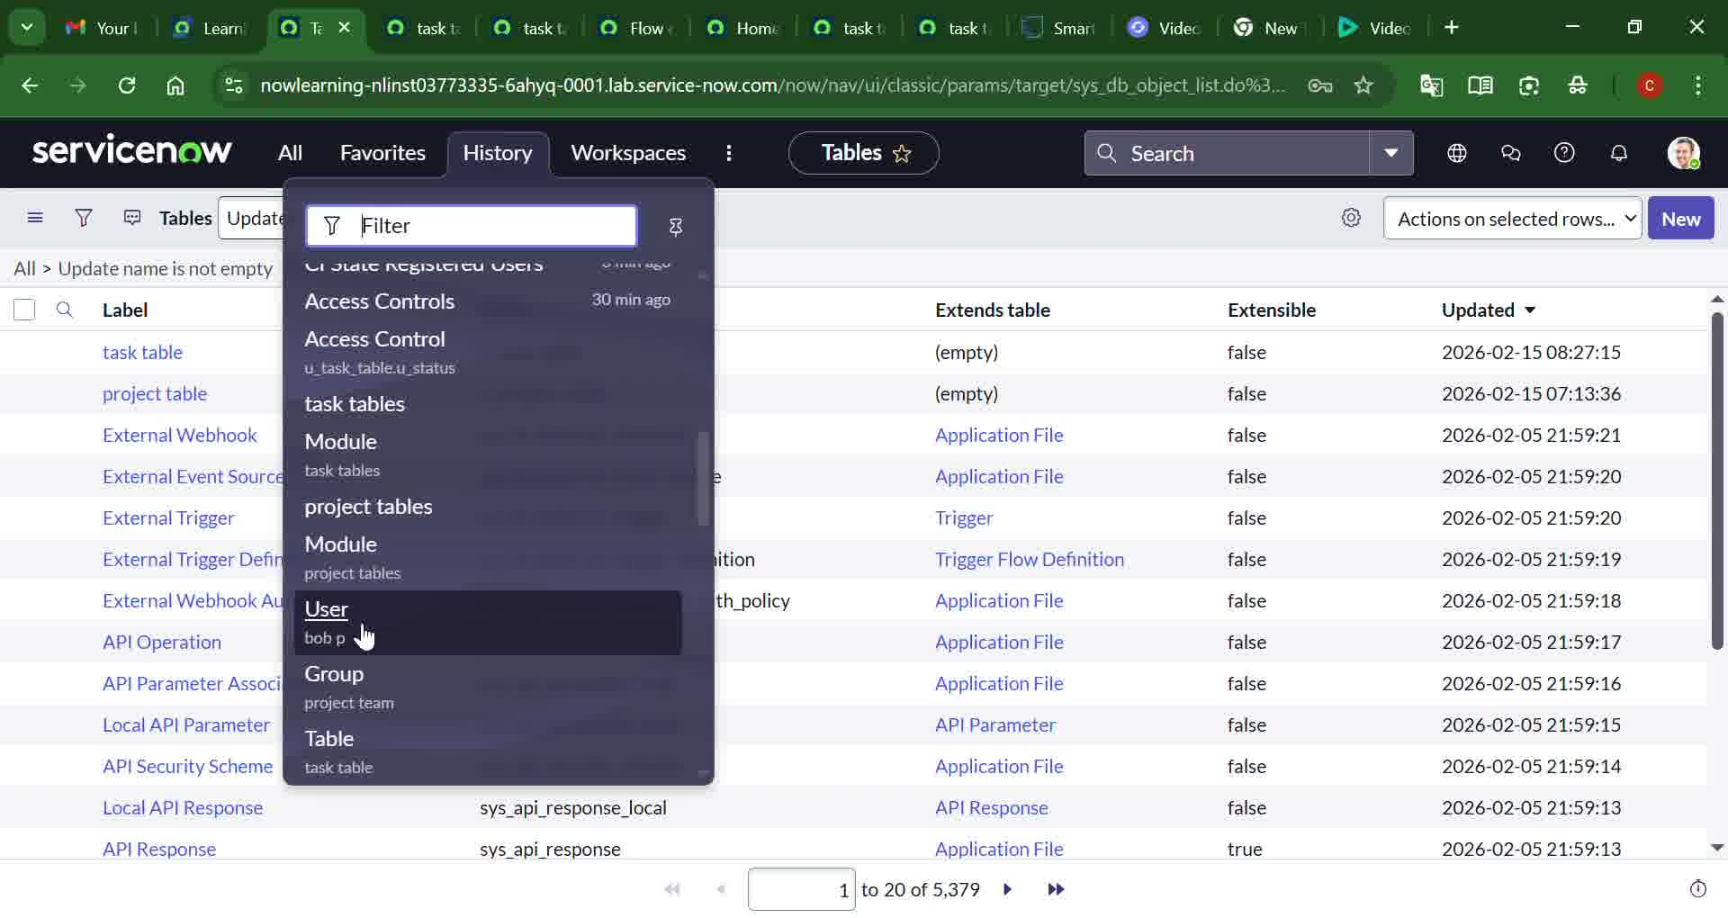 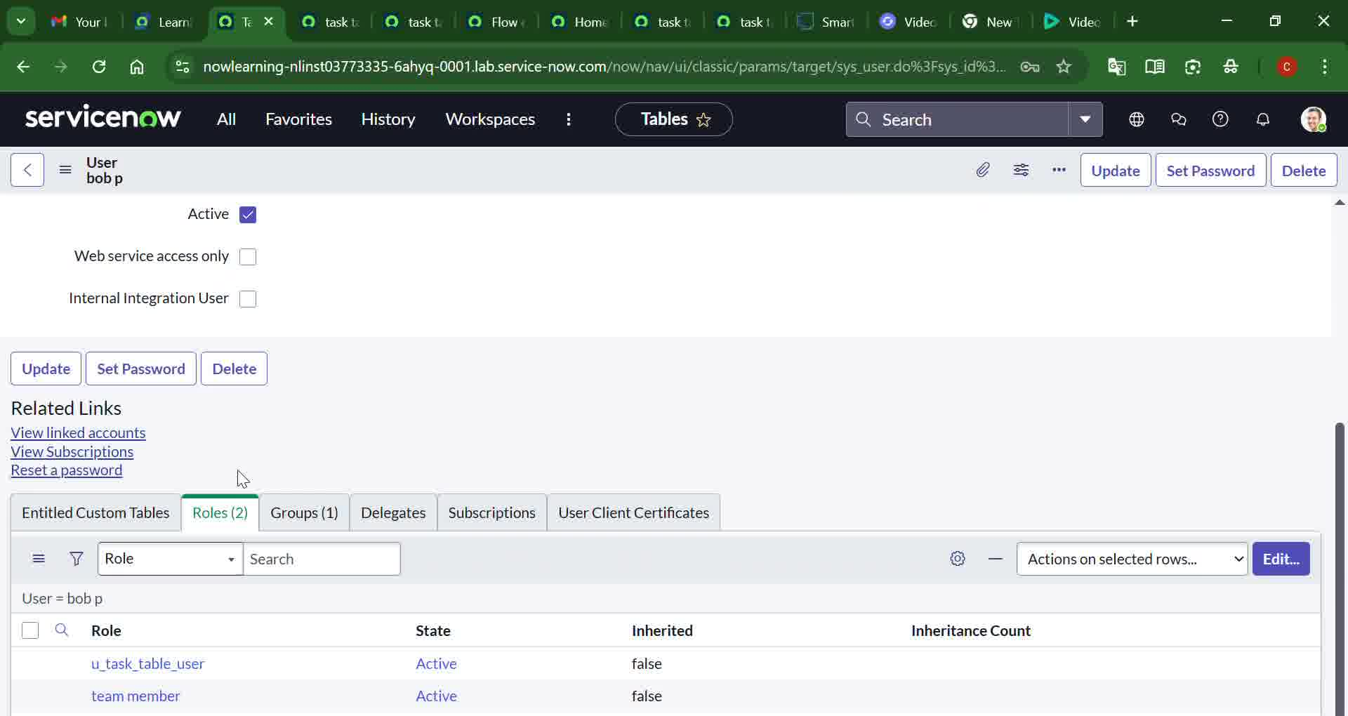

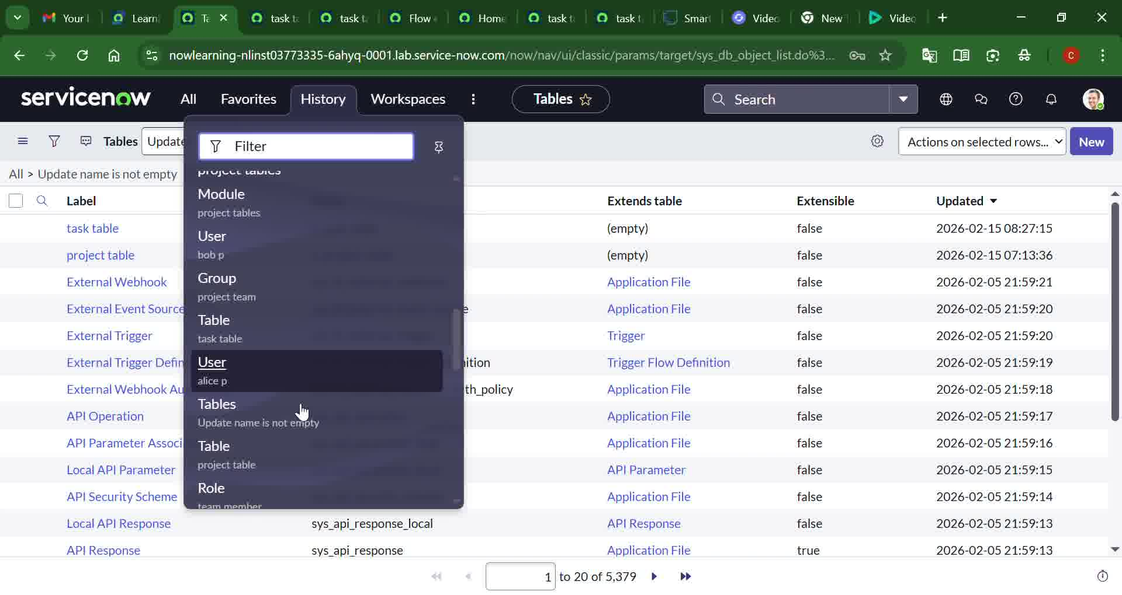 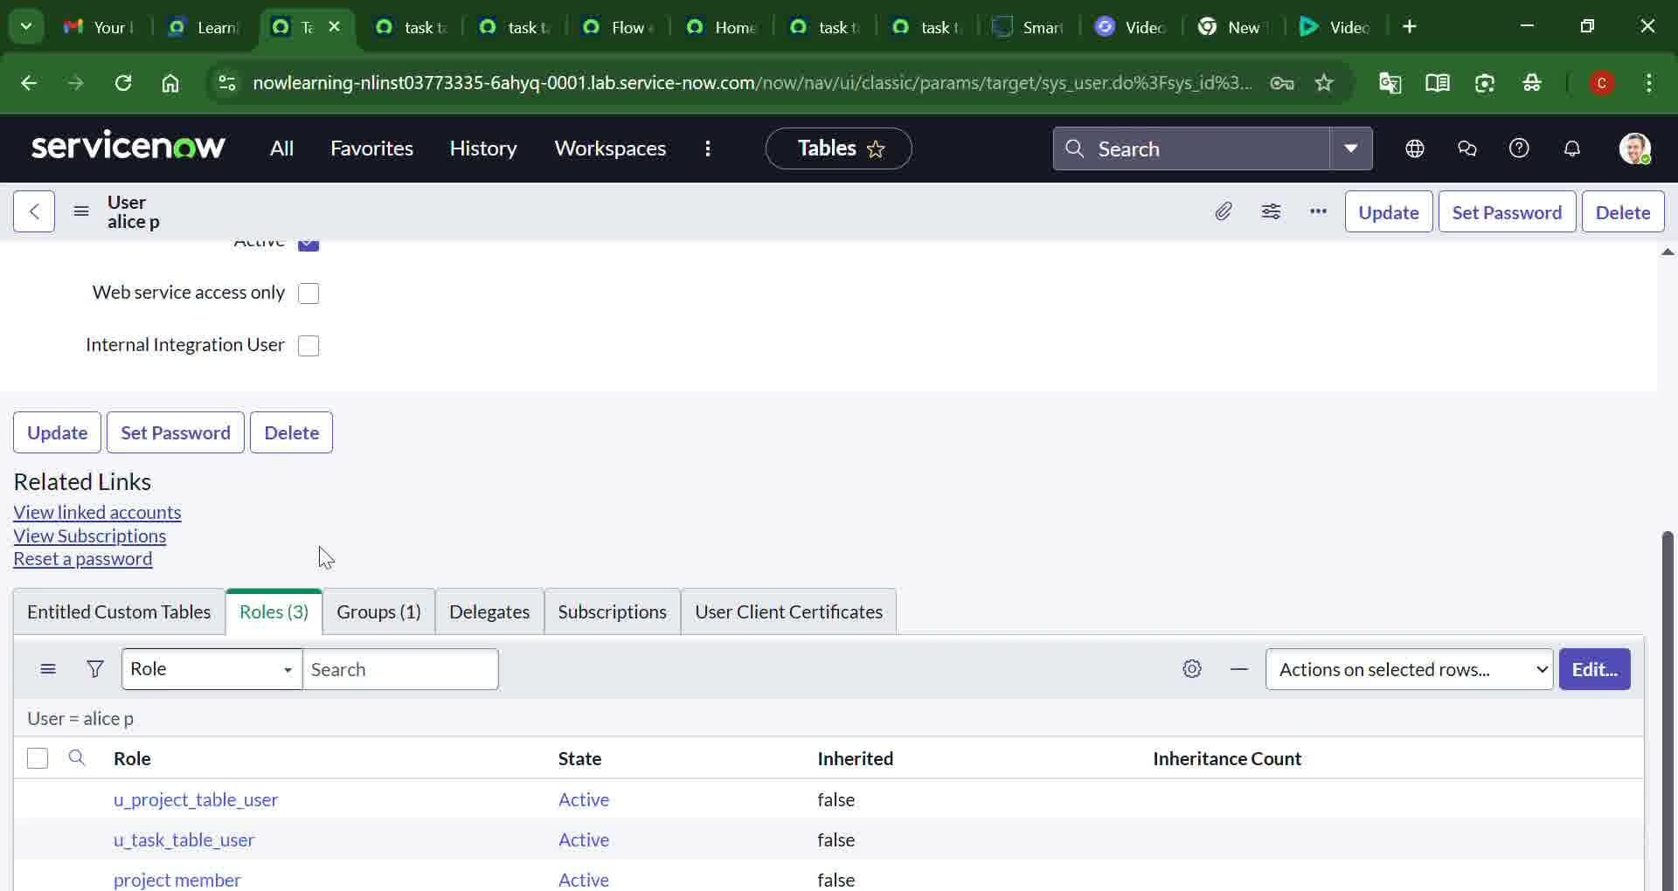

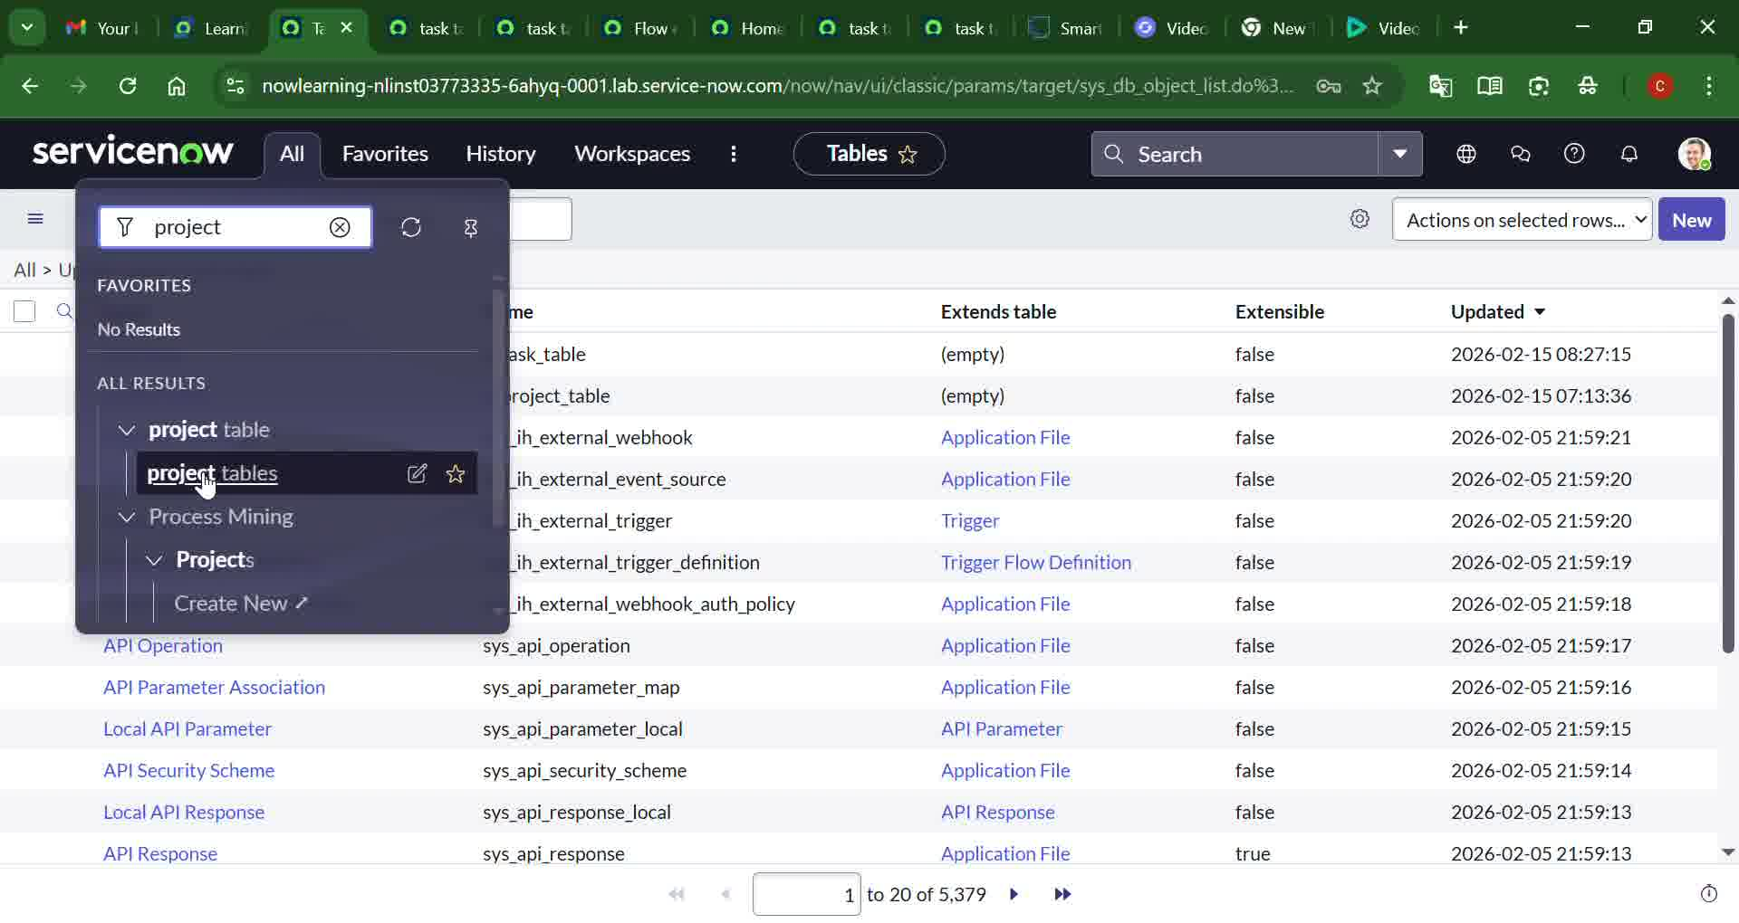 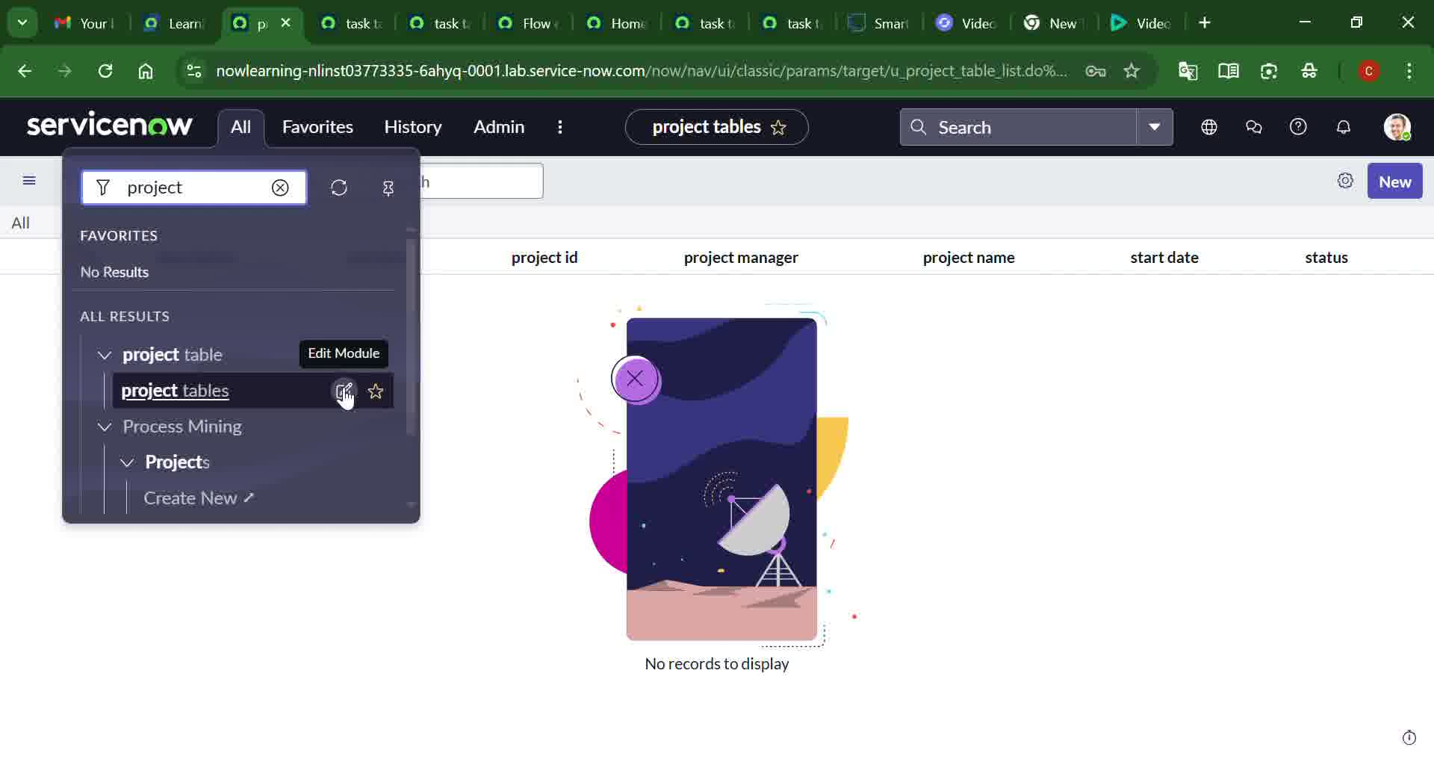

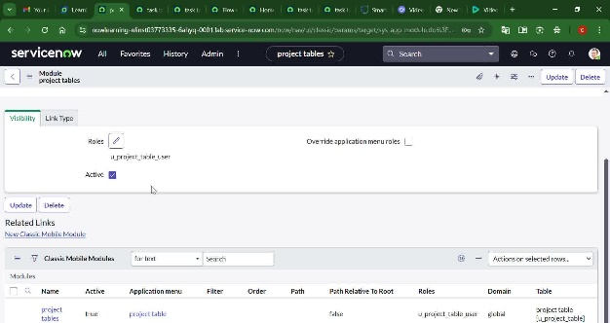 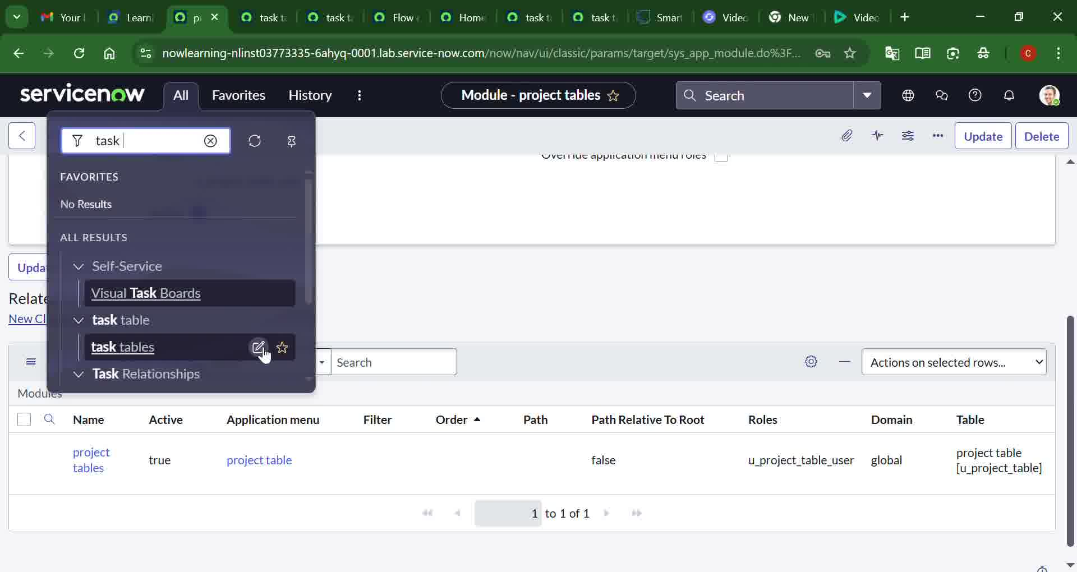

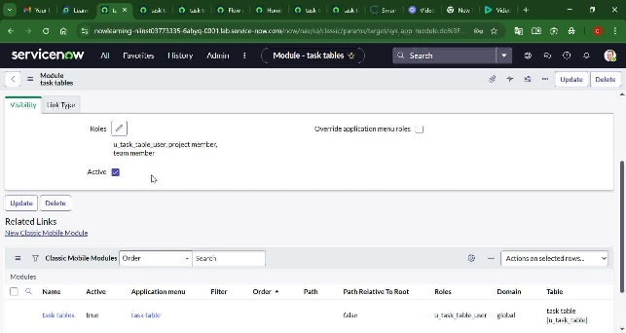 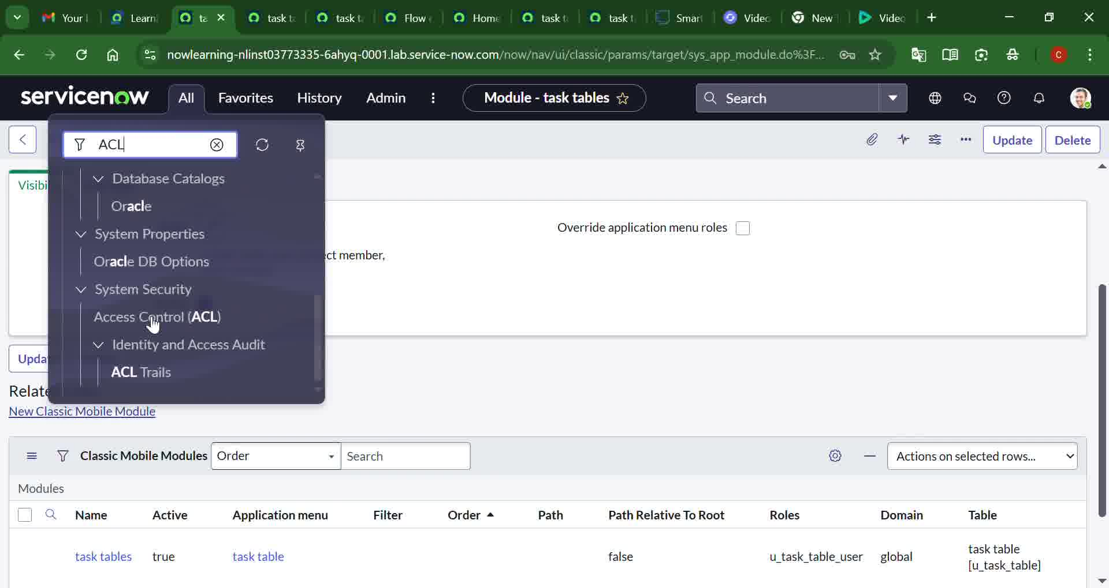

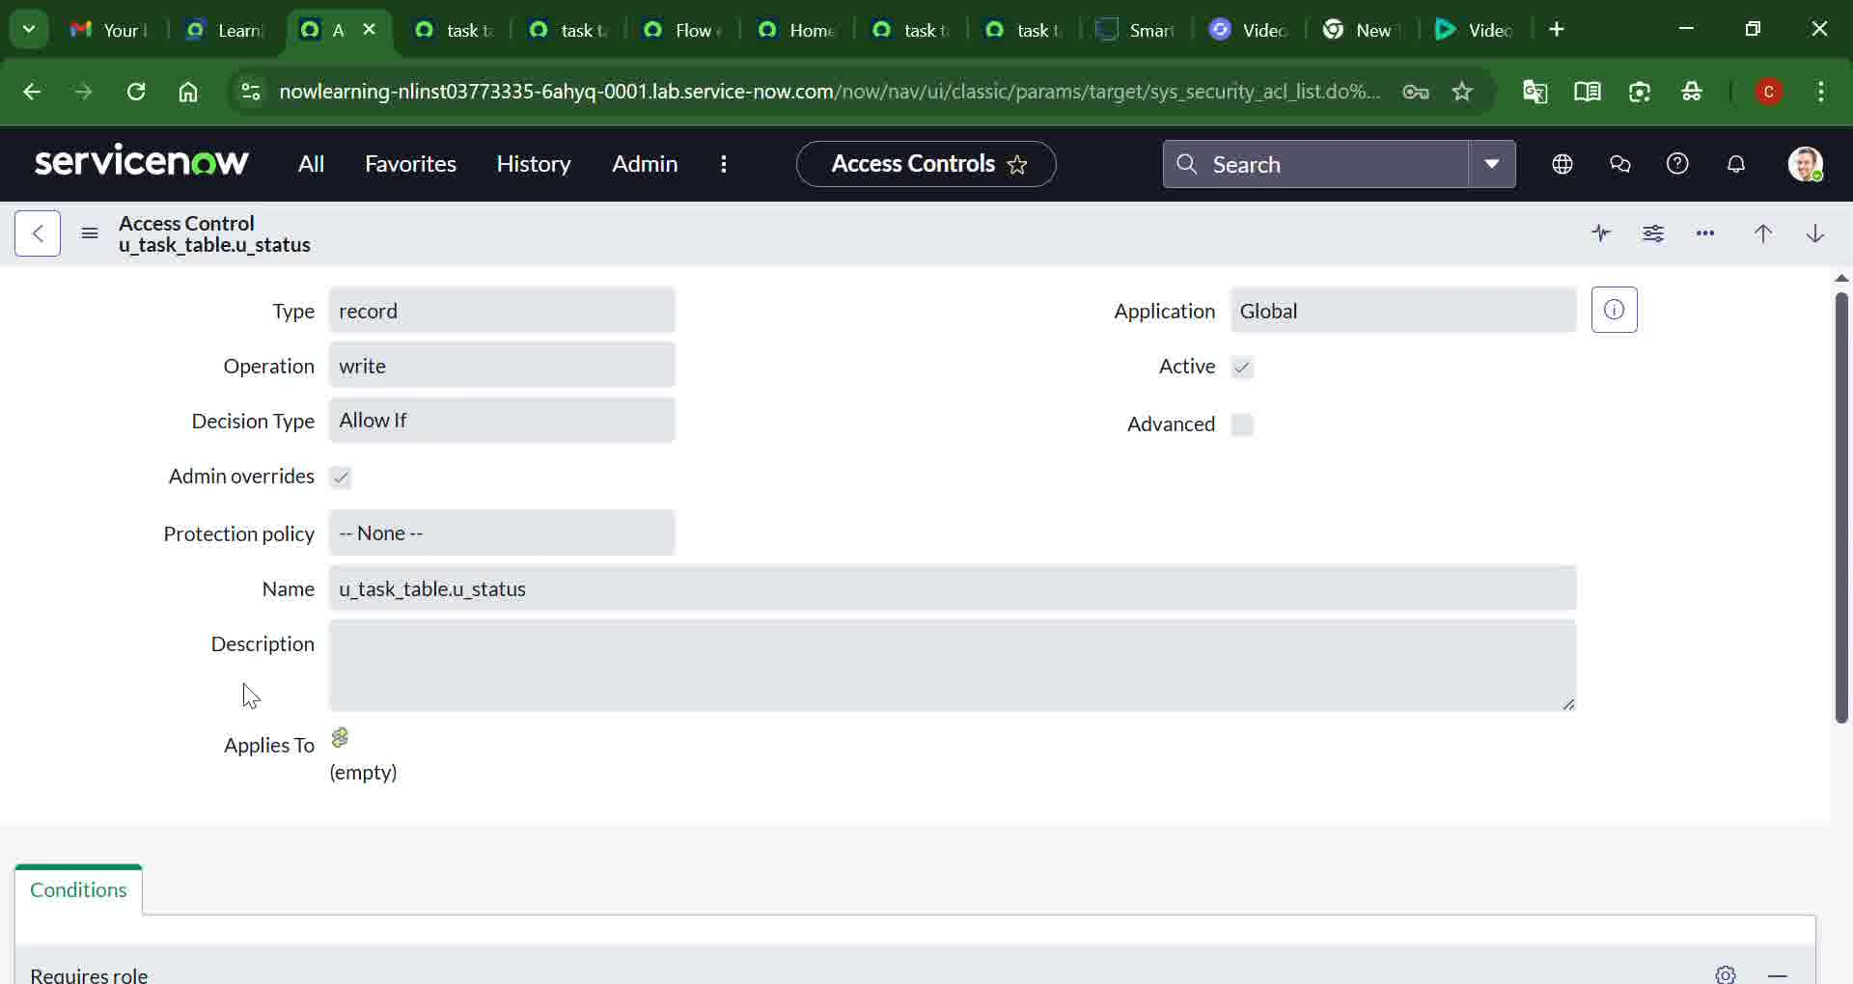 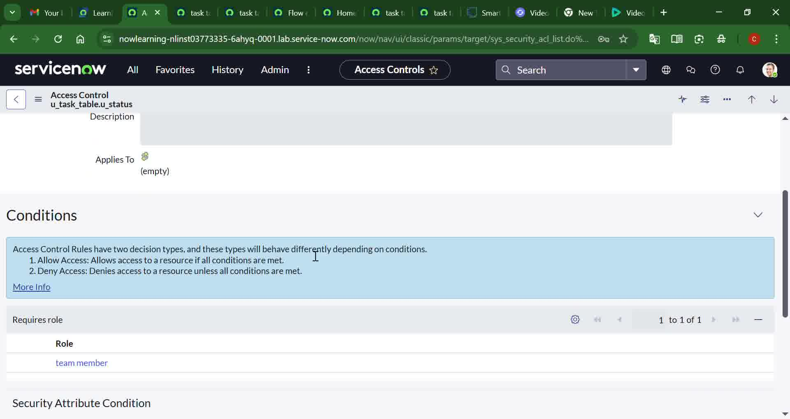

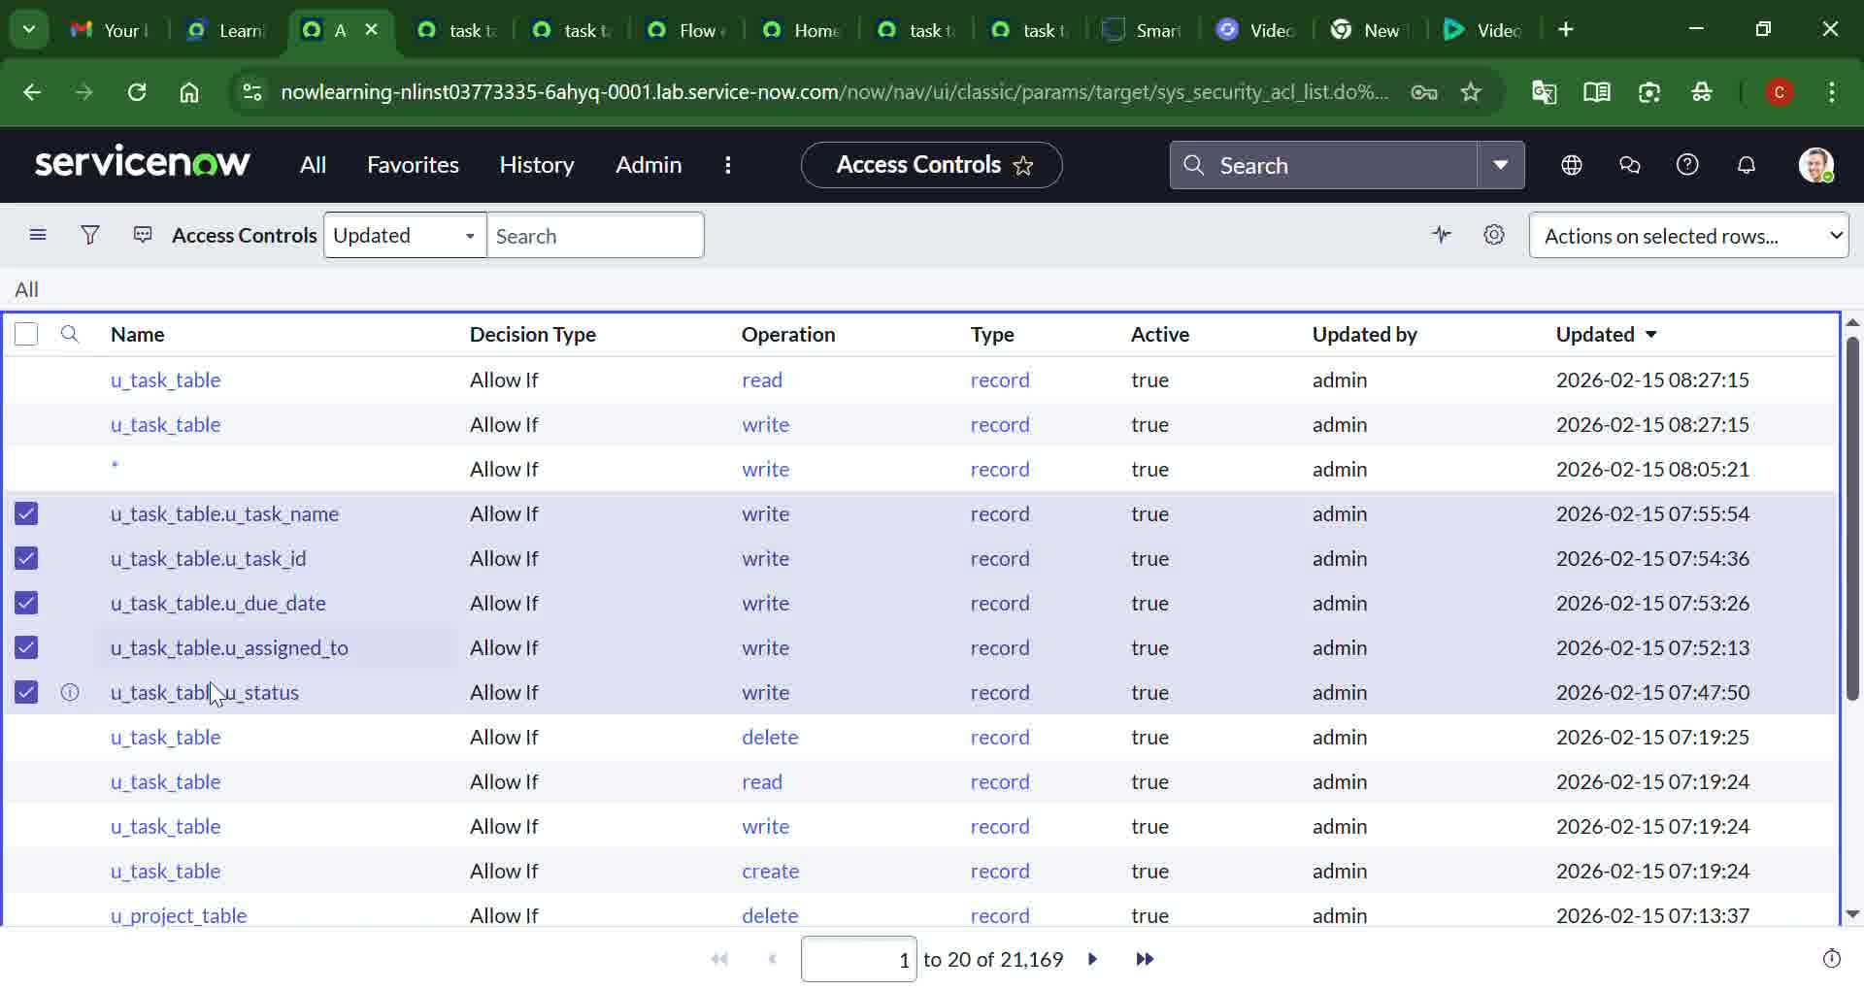 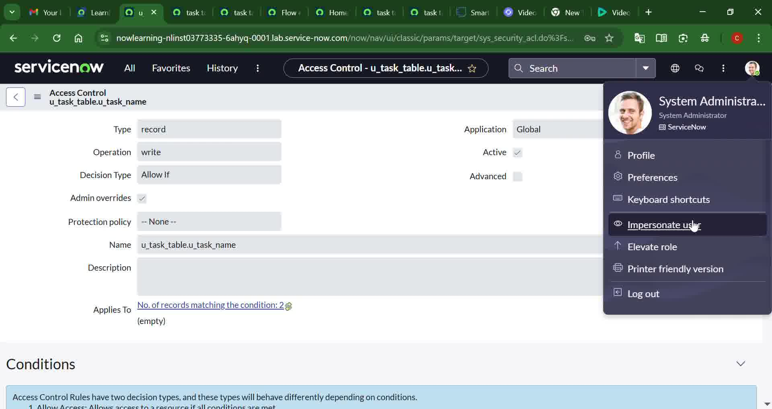

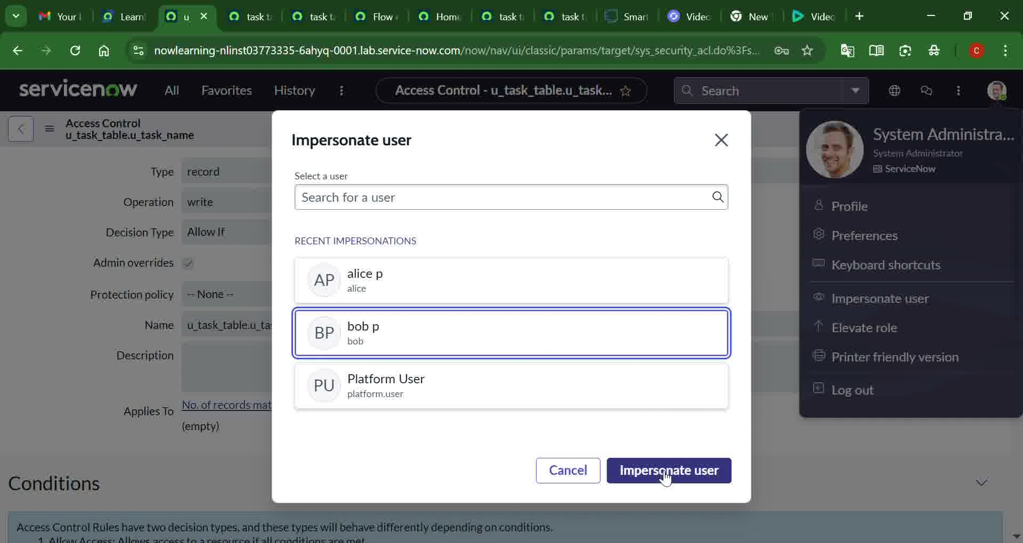 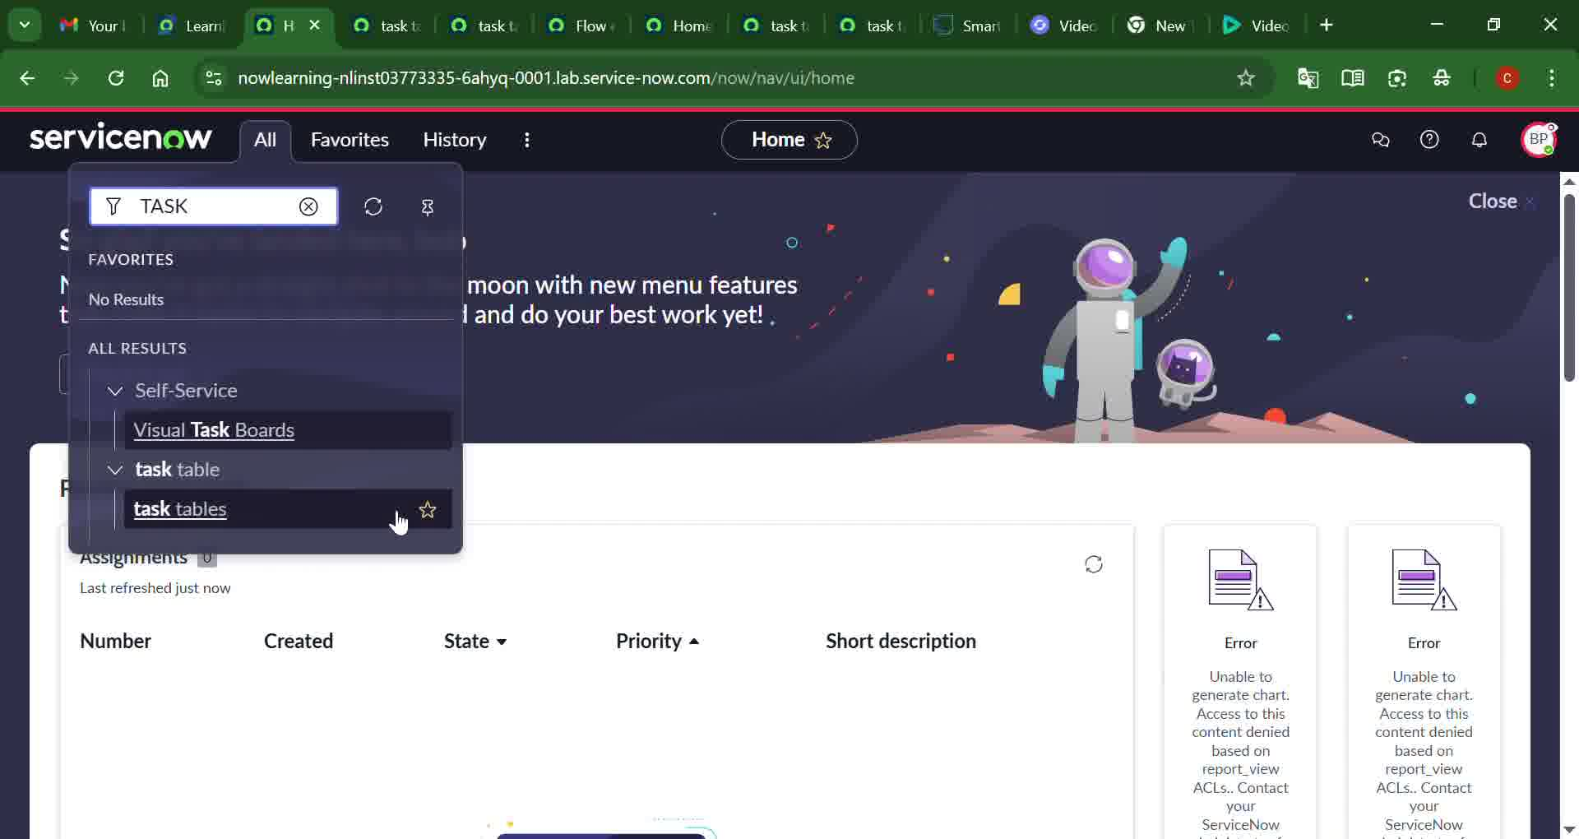

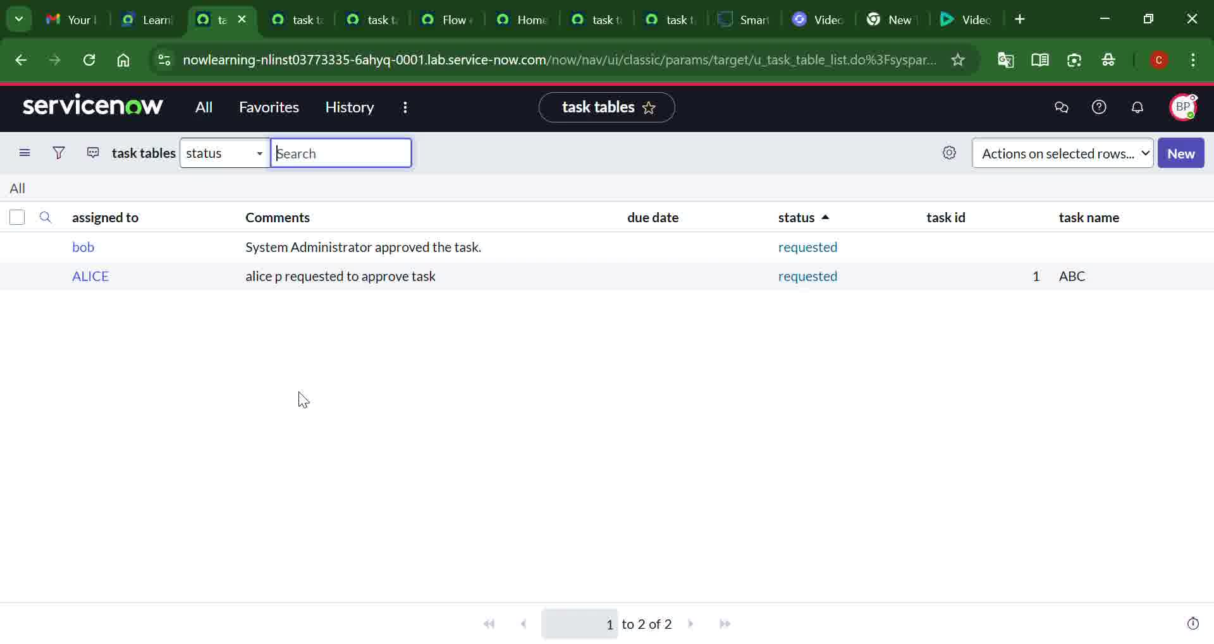 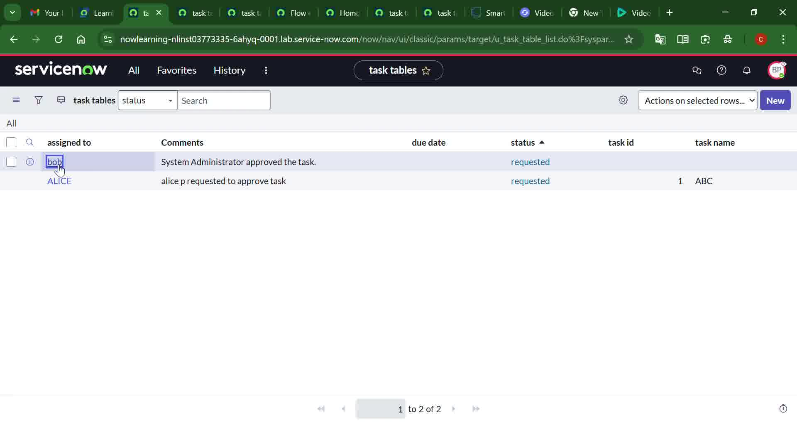

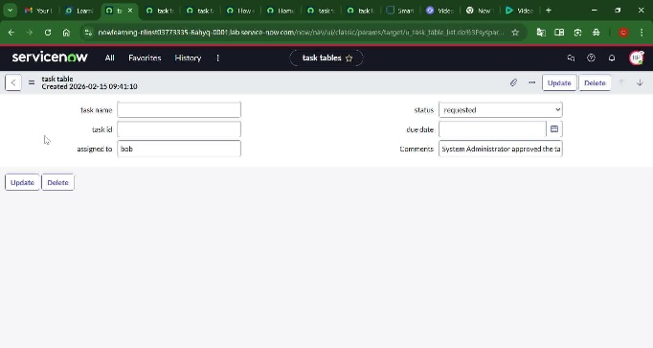 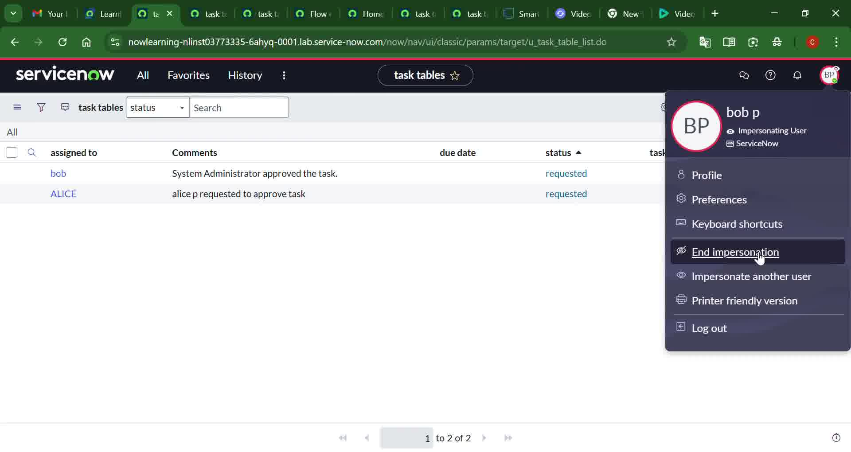

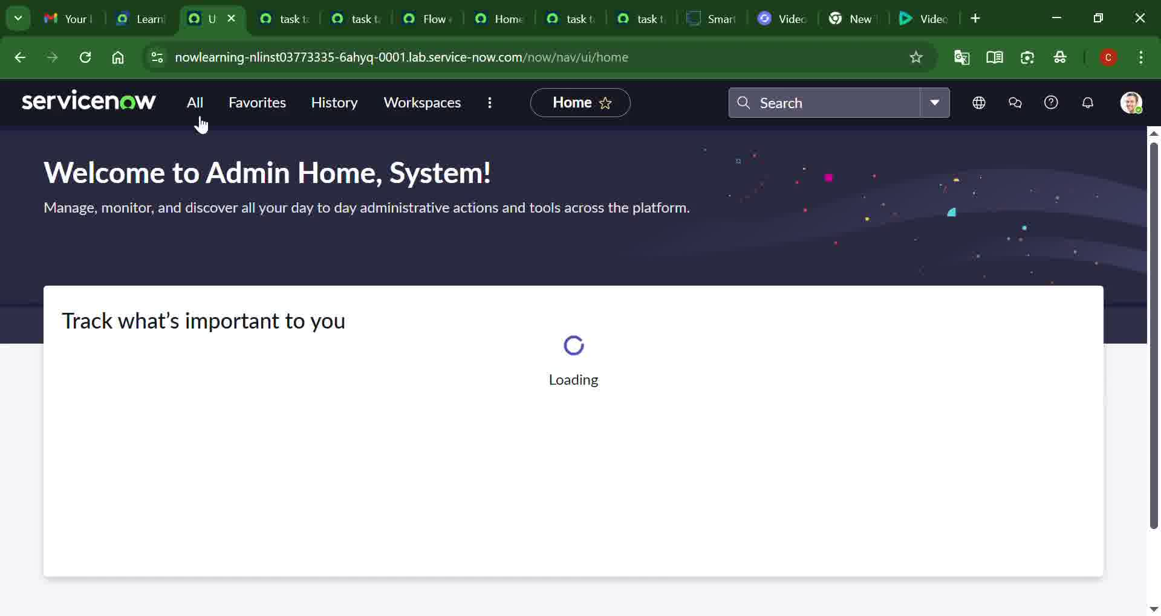 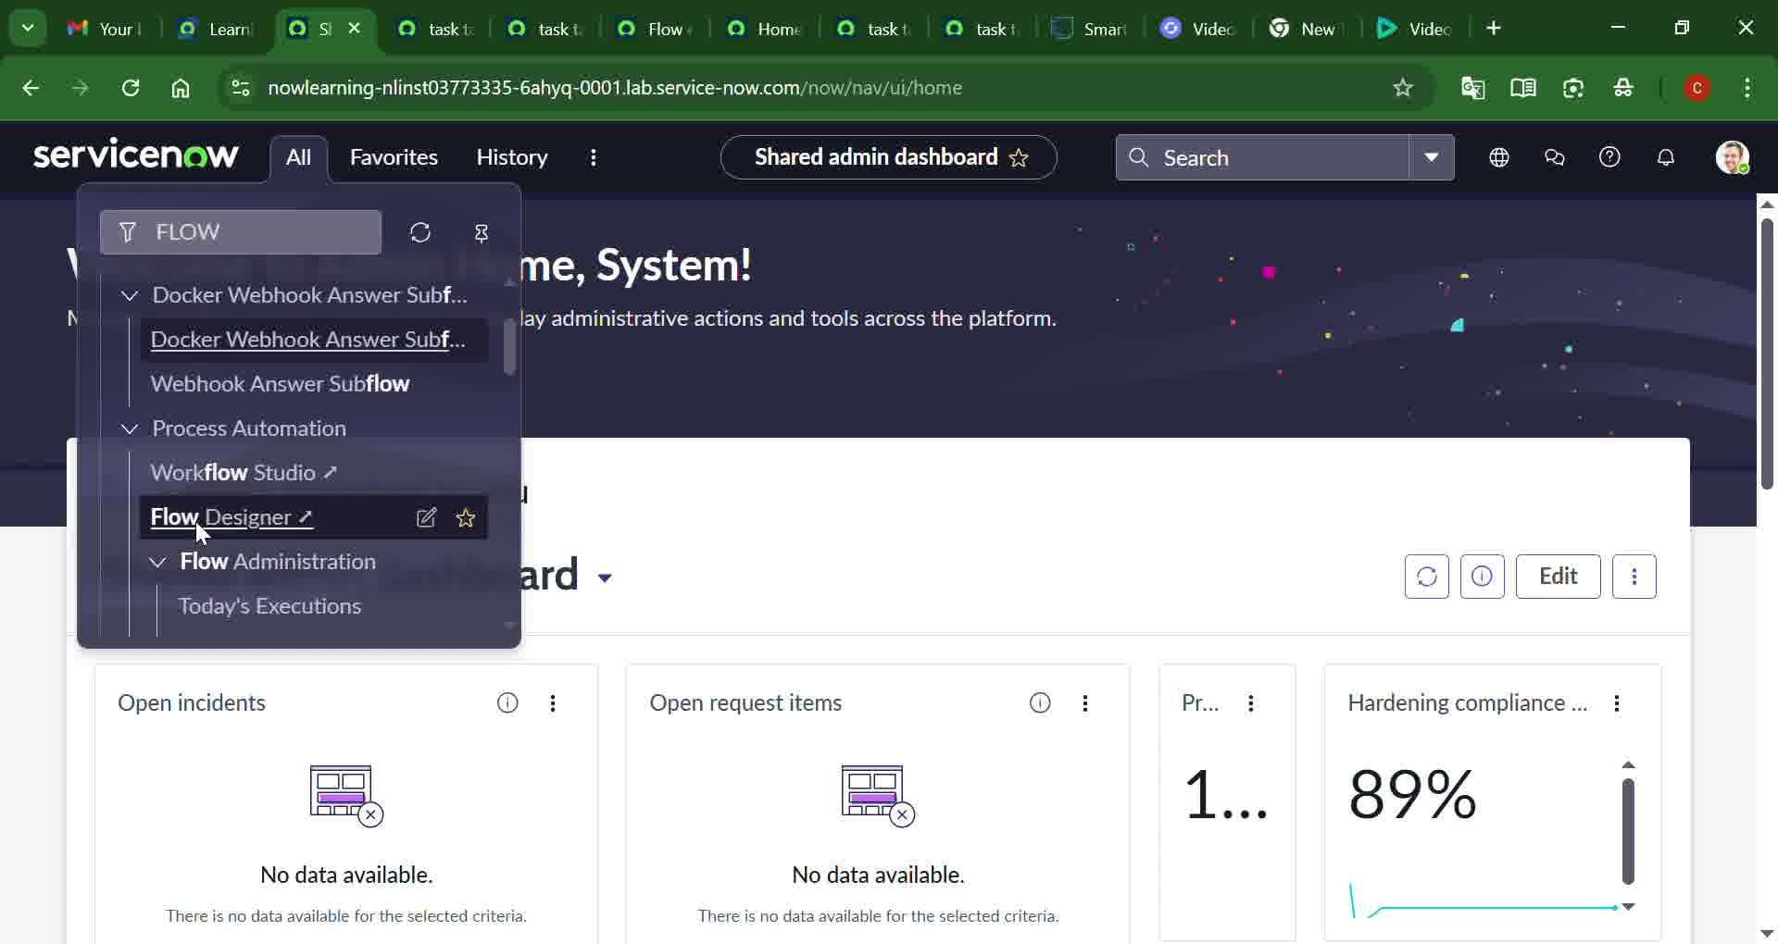

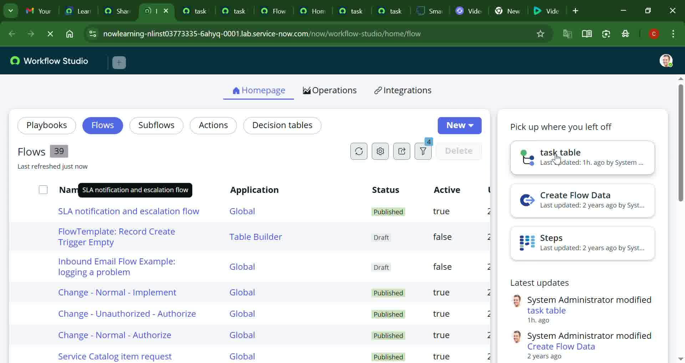 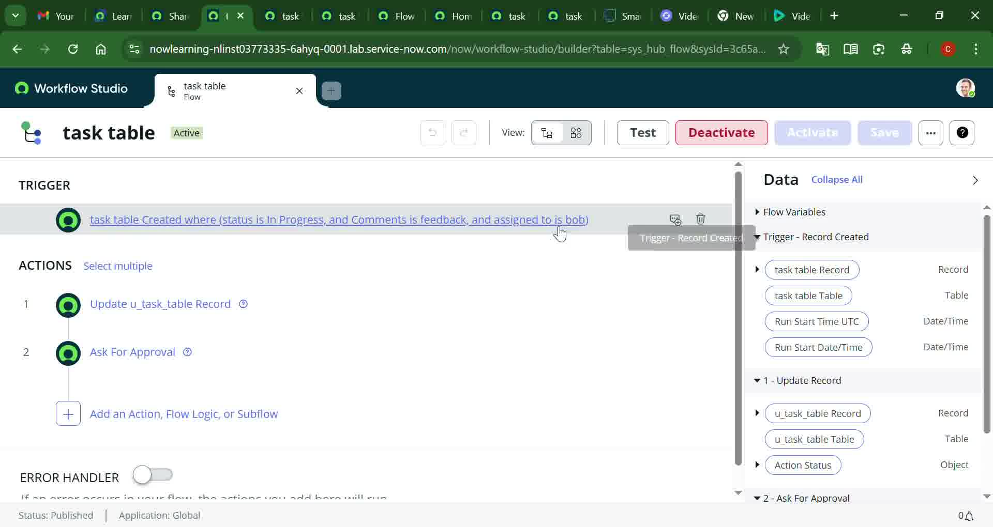

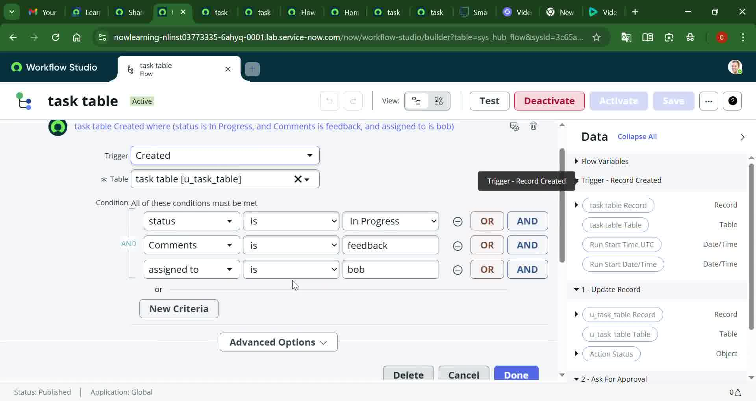 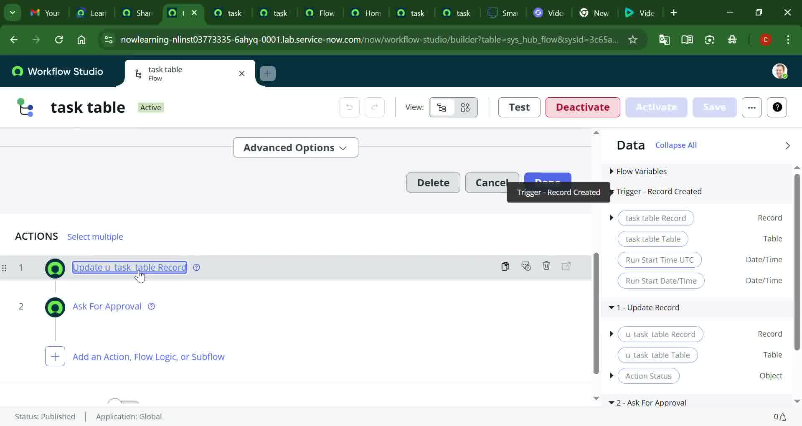

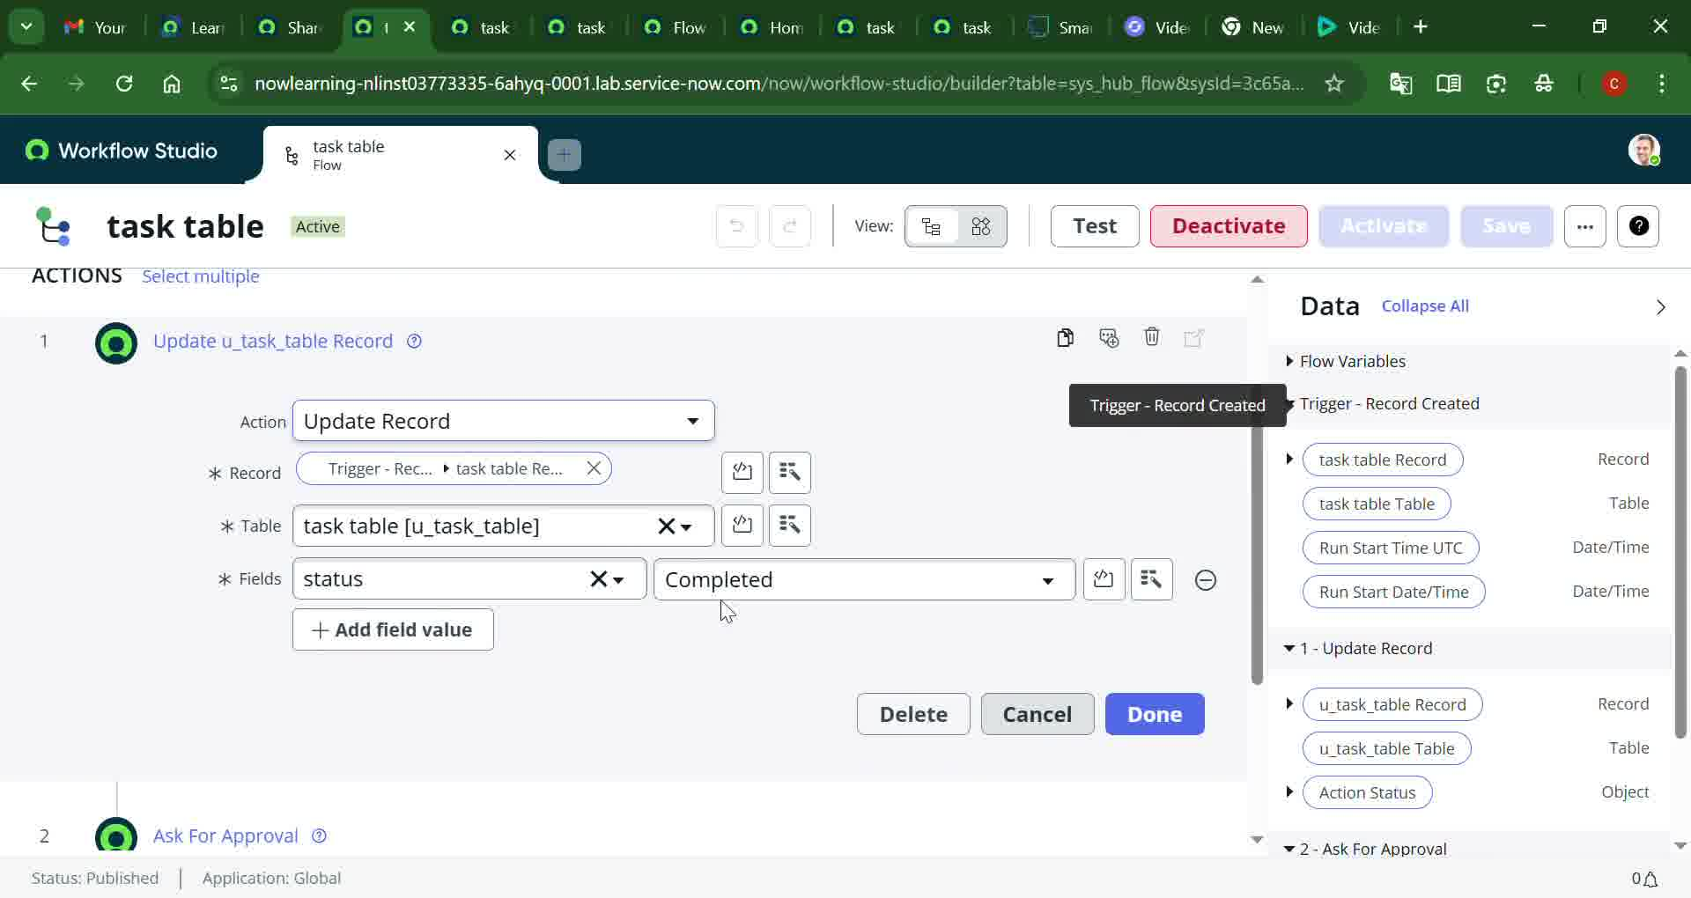 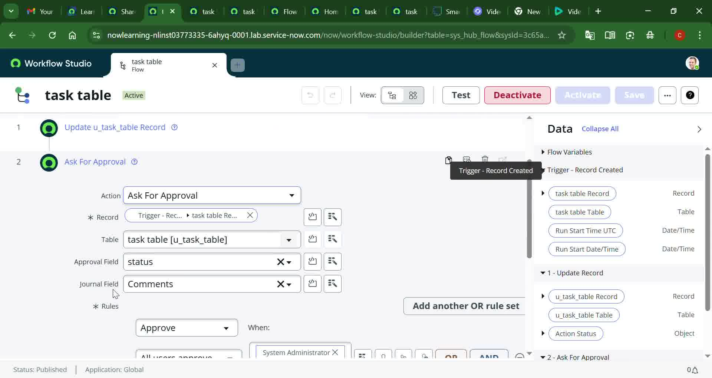

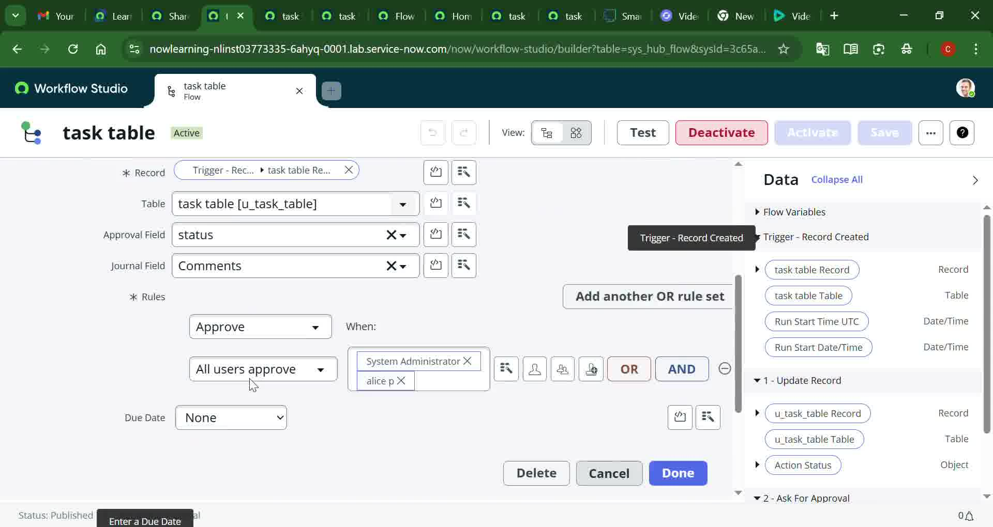 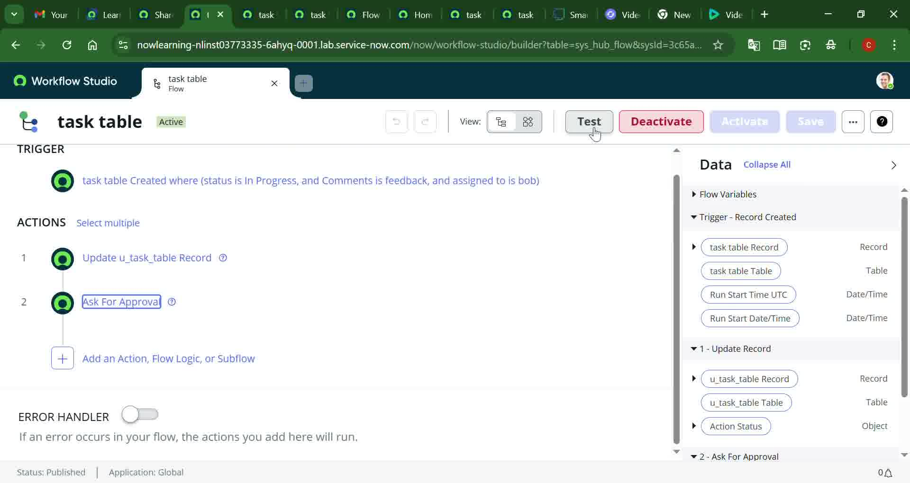

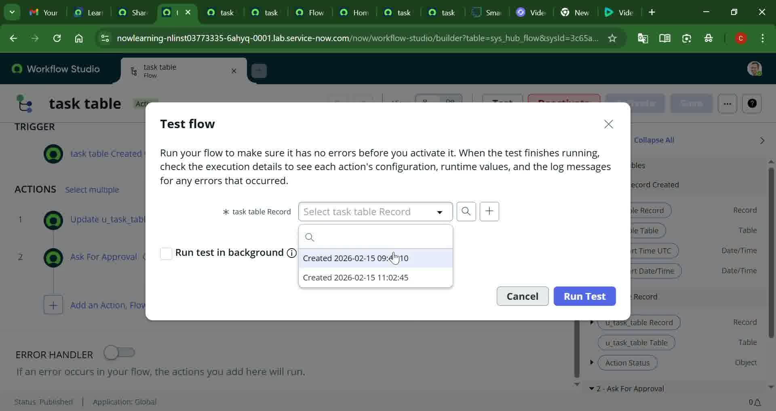 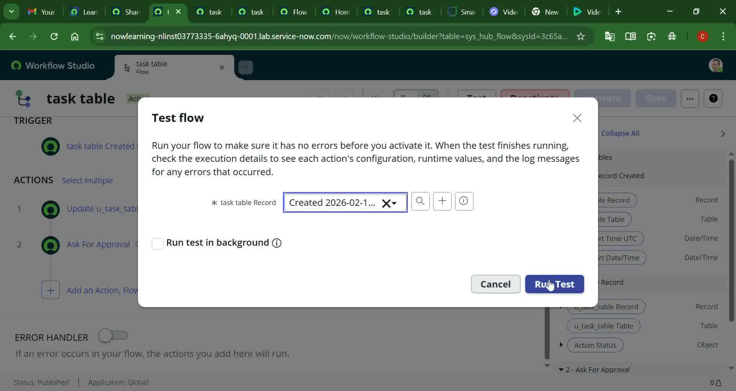

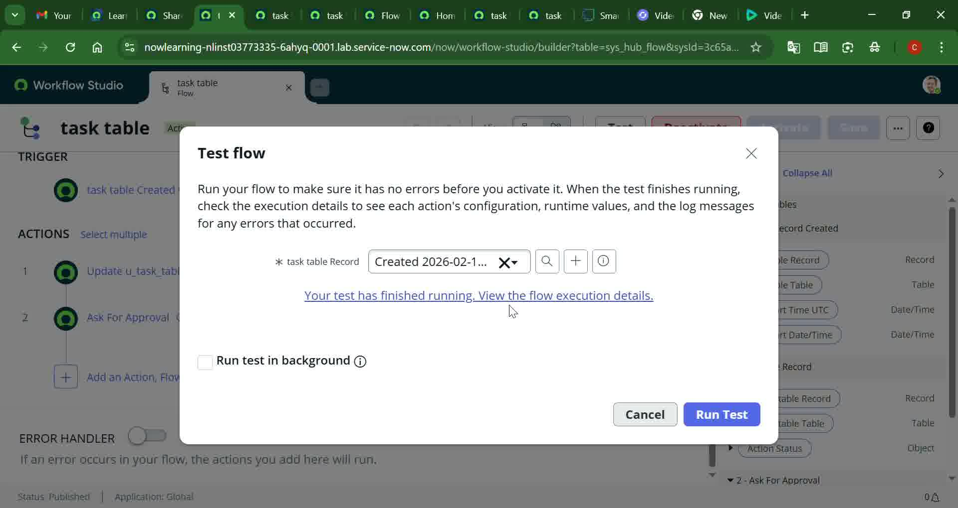 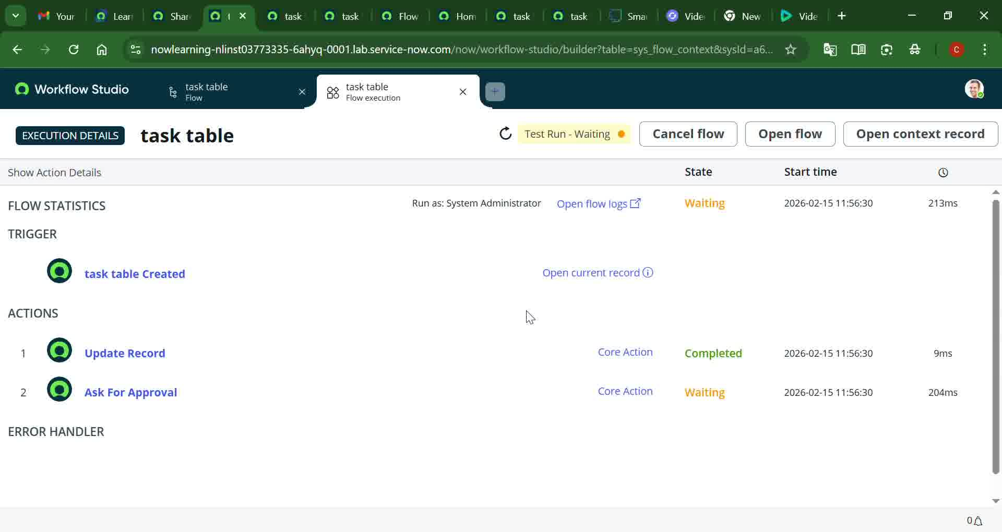

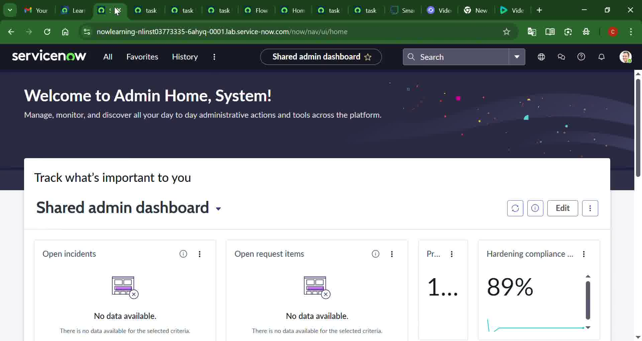 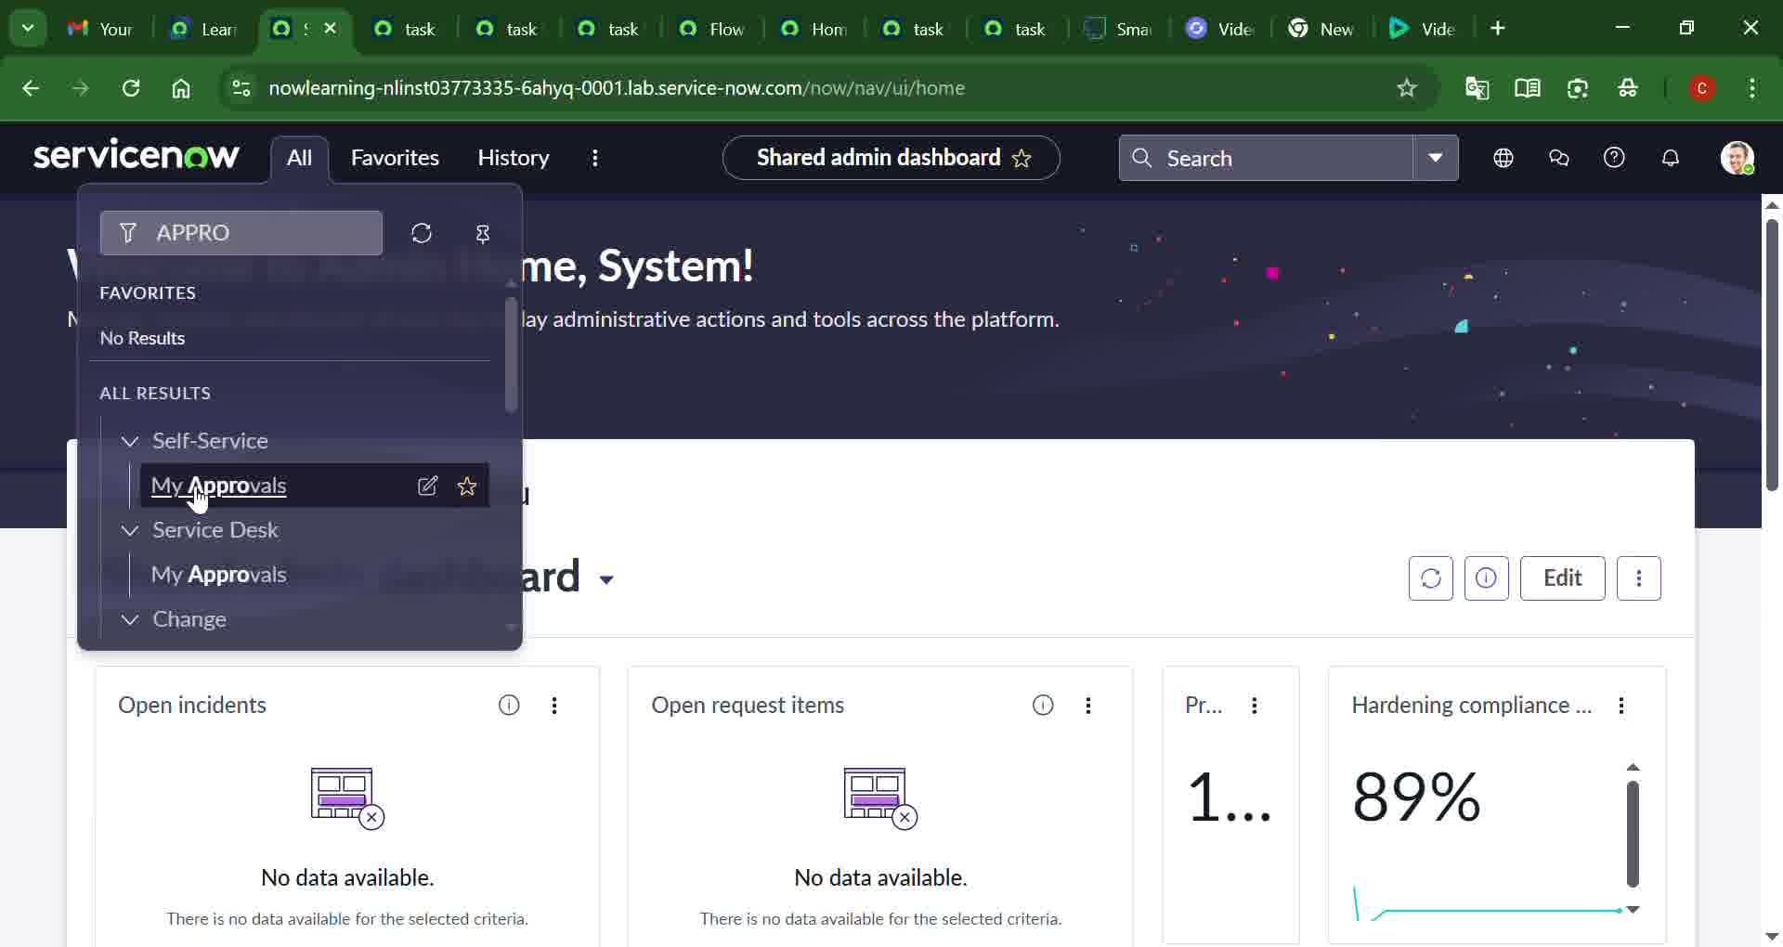

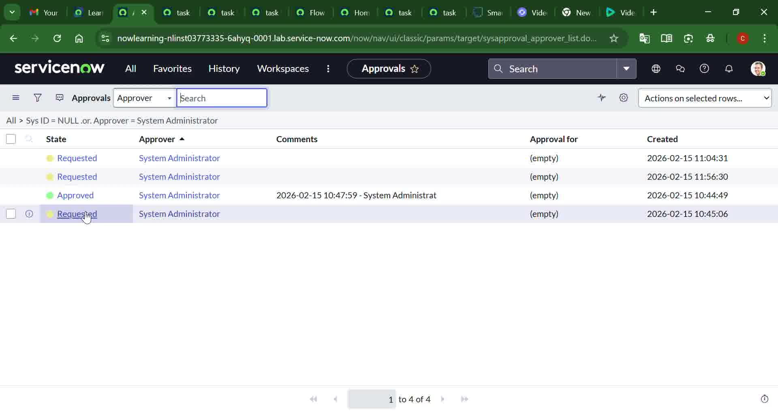 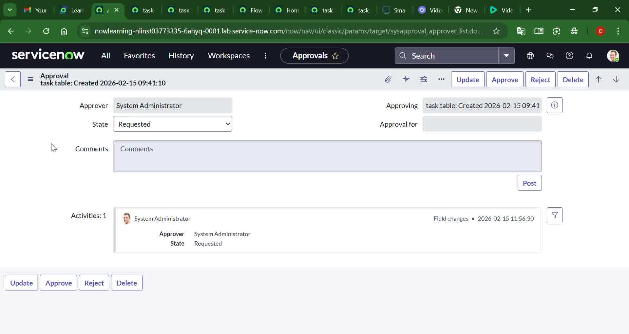

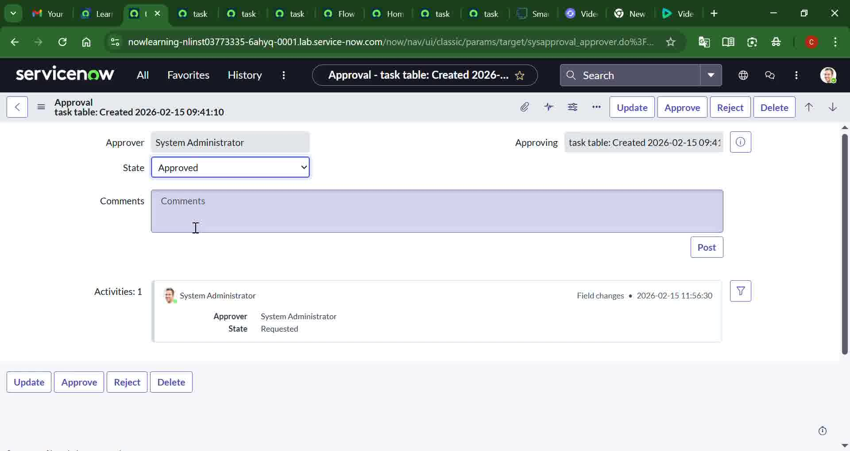 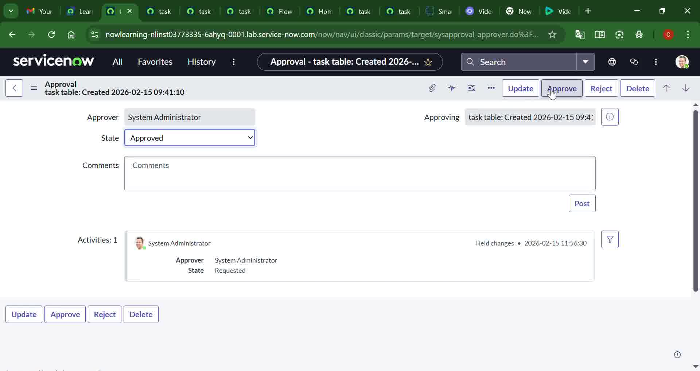

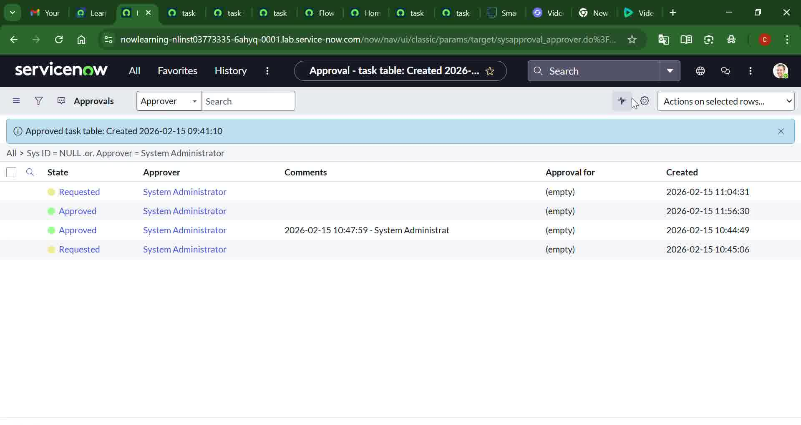 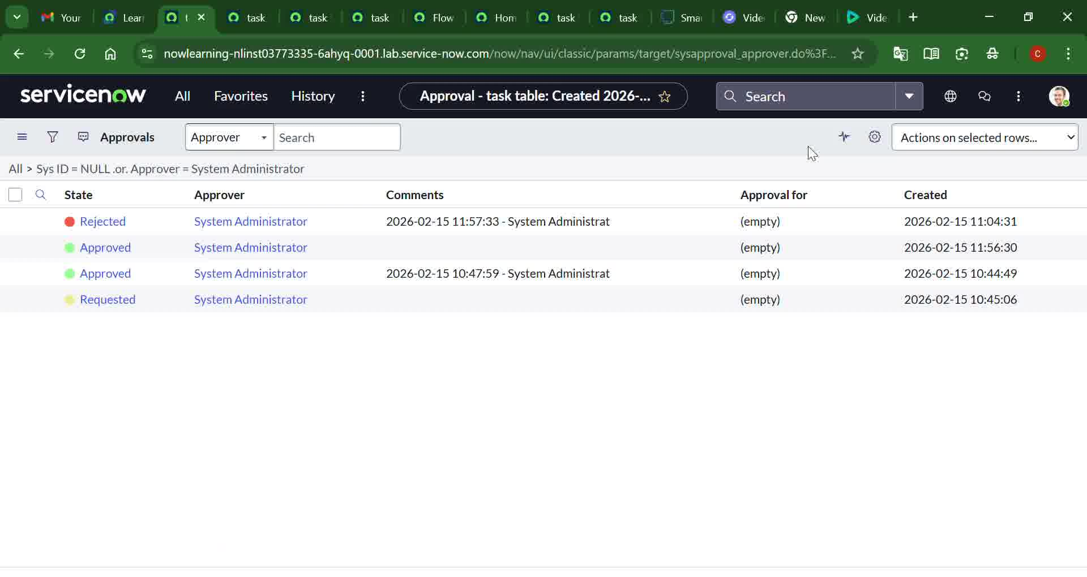

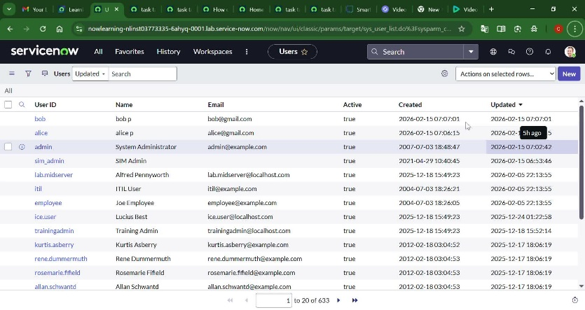

**8. ADVANTAGES & DISADVANTAGES**

**Advantages**

* Clear role-based access control
* Improved task accountability
* Automated workflows reduce manual effort
* Secure and centralized system

**Disadvantages**

* Initial setup complexity
* Requires ServiceNow platform access
* Limited customization without advanced scripting

**9. CONCLUSION**

This project successfully demonstrates how optimized user, group, and role management combined with workflow automation can significantly improve project execution. By leveraging ServiceNow’s capabilities, the system ensures security, accountability, and efficient task management, making it suitable for small to medium-sized teams.

**10. FUTURE SCOPE**

* Integration with email and notifications
* Advanced analytics and reporting
* Support for larger teams and multiple projects
* AI-based task prioritization

**11. APPENDIX**

**GitHub & Project Demo Link**

* GitHub: <https://github.com/srikanthramagani/ServiceNow.git>
* Demo Link *:* [*https://youtu.be/u3n3cW3mphM*](https://youtu.be/u3n3cW3mphM%20)